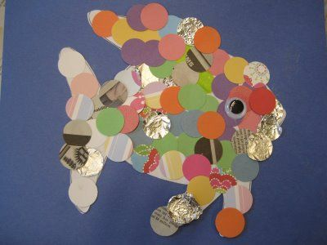
What is this type of artwork called?

Name an artist who creates this type of artwork:
How would you create a ‘mosaic’?

Describe what it means to change the ‘composition’ of your picture:

Describe how you could add shadow to the image:

Describe what it means to add highlight to the image:

