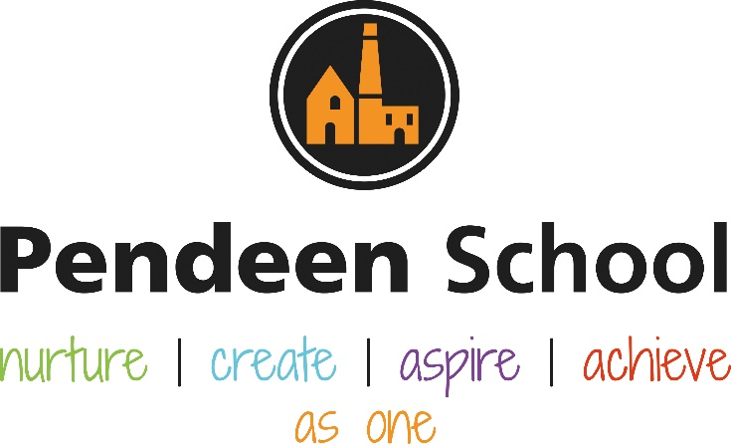

EYFS Guidance (Upated December 2022)

Pendeen School EYFS Principles

Intent
At pendeen School our aim is to create learning environment and relationships which support, enhance and invite children’s curiosity, confidence and individual competence to flourish regardless of backgrounds, circumstances or needs. We aim to work collaboratively with parents and carers to encourage independent, enthusiastic learning who thrive and reach their full potential. It is our intent that children who enter our EYFS begin their lifelong learning journey by developing physically, verbally, cognitively and emotionally whilst also embedding a positive attitude and a love of learning.
To ensure children make outstanding progress in Pendeen EYFS, it is our intent to take into consideration their starting points and needs of our pupils as they begin their learning journey. Every child has access to a broad, balanced and differentiated curriculum which prepares them for now and for the future in terms of opportunities and experiences which consider our local cultural capital. Following personal interests and individual needs, allows us to plan and provide opportunities throughout our EYFS curriculum to support learning and development and achieve their next steps.

Our EYFS curriculum aims to enable our children to be:
Competent and creative learners; who are curious about the world around them.
Secure and confident; who enjoy coming to school and learning new skills and knowledge building on their existing learning.
Skillful communicators; who connect with others through language and play, ensuring that they play in a vocab rich environment.

We strive for effective practice to support the development of the whole child. Our aim is to ensure the best for every child through high-quality care which has the child’s experience at the heart of our ambitious curriculum. Post-covid, we acknowledge that children have missed opportunities to develop in social contexts and therefore strive to support a child in developing their ability to self-regulate through opportunities which focus their thinking, persist and plan ahead.

Implementation
At Pendeen School we follow the Early Years Foundation Stage Framework and Development Matters to underpin our EYFS curriculum. This revolves around: the seven areas of learning, Communication and Language, Personal, social and emotional development, Physical development (gross motor and fine motor skills), Literacy, Mathematics, Understanding the world, Expressive arts and design; and links to our year 1 curriculum taking into account the knowledge and understanding children require for their future learning within the National Curriculum.

In planning and guiding what children learn, we understand that children develop at different rates and adjust our practice accordingly utilising the three characteristics of effective teaching and learning which are:
- playing and exploring – children investigate and experience things, and ‘have a go’
- active learning – children concentrate and keep on trying if they encounter difficulties, and enjoy achievements
- creating and thinking critically – children have and develop their own ideas, make links between ideas, and develop strategies for doing things

Pendeen School begins building a picture of the whole child before starting in September to enable staff to build relationships with the child and their families, supporting a smooth transition into primary school from nursery and home. This is done through children attending Stay and Play sessions during Summer term 2 in Kynsa class and Kynsa’s outdoor areas; home visits to meet with parents and see children in their home environment; meeting with key workers from nursery settings and a parent welcome meeting which includes outside agencies such as the school nurse.

When children begin in September, a baseline assessment is carried out through the statutory Reception Baseline Assessment and a teacher assessment via the school’s assessment system Target Tracker. This informs the child’s starting point and supports the teacher in developing a Long Term Plan for the rest of the year. The yearly long-term plan is reflected within Pendeen Sequencing UTW EYFS Year A and will develop throughout the year alongside the children’s development.

Literacy
In Early Years and KS1, all children will follow the Read Write Inc scheme for phonics, giving a systematic, synthetic phonics introduction to reading with complete fidelity to the scheme since it provides the best outcomes for children. A 20 minute daily phonics lesson is taught with time extending across the year as children’s abilities develop. By the end of the year, all EYFS children will complete a 40 minute phonics lesson. More information on this implementation can be found in our English Guidance Document. We develop a love of reading within the EYFS through utilising Talk Through Story which models reading of stories, develops the ability to discuss stories as well as builds vocabulary. The years stories can be found within Pendeen Sequencing UTW EYFS Year A. Additionally, nursery rhymes are sung throughout the day providing children with the opportunity to learn through repetition. Storytime is also utilised to have a special moment to share a book. The Kynsa Fab 5 reflects the five stories in which the children enjoy reading as well as a basket of favourite stories which will be revisited and added to throughout the year.
Writing is also developed within the scheme, however, opportunities to develop independent writing is taken each week and recorded within each child’s writing book in line with the rest of the school. There is a defined phonics area within the classroom which homes all the resources for RWI including the planning folder which directs learning.

Mathematics
Maths in Pendeen’s EYFS strives to provide the foundations that children need to achieve in maths. To ensure coverage of the EYFS curriculum, a separate document (Pendeen School Long Term Maths Plan – EYFS) has been created to represent what maths looks like in EYFS at Pendeen School which includes a week by week breakdown of the focus of learning linked to the White Rose EYFS Scheme of Learning with examples of how planning takes in to consideration the focus for the week. The Mastering Number Programme is also implemented which develops children’s number sense. A daily 40-minute structured maths lesson is taught. A blue folder is kept within the classroom which encompasses weekly planning as well as medium term planning.

PSED
Relationships, social, health and economic (RSHE) education is a planned programme of school-based learning opportunities and experiences within the PSHE curriculum that deal with the real-life issues children and young people face as they grow up. Curriculum sequencing can be found within Pendeen Sequencing PSED EYFS Year A. Equally, a fluid and flexible approach is imperative within our EYFS setting where adults support children to develop the language and skill of self-regulation at any given opportunity. Areas within the classroom setting are utilised to support the development of this.

Communication and Language
Communication and Language is modelled from the start where children are actively encouraged to speak in full sentences. Adults constantly model the skills needed in order to be successful communicators. The understanding of questions is developed through the year and can be seen within medium term plans.

Physical Development
Within the classroom, there is a defined area which supports the development of fine motor skills – the writing area. This is alongside opportunities throughout the rest of the classroom to development motor skills. A clearly defined construction area supports the development of gross motor skills which provides a variety of different sized resources. Additionally, daily handwriting activities happen to develop children’s fine motor skills. Children receive 2 hours of physical education each week. One hour is through REAL PE Foundation. Children take part in the Daily Mile during lunchtime.

Expressive arts and design
There are ample opportunities within the classroom setting which provide opportunities for development within the expressive arts and design. Additionally, there are separate sequencing documents for art, design and technology, and music which outlines development of knowledge, understanding and skill within these subject areas.

Understanding the world
Each half term there is a unique topic taught. These are:
Autumn 1 – Ready, Steady, Go
Autumn 2 -Sparkle and Shine
Spring 1 – Child-initiated (2022-2023 academic year: My Gumpy’s Travels)
Spring 2 – Child initiated (2022-2023 academic year: Once Upon A Time)
Summer 1 – Kings and Queens (considering the King’s coronation) and Minibeasts
Summer 2 – Beside the Seaside

Seasons are taught throughout the year which consider changes within the local environment. A medium term plan is written before the start of each term which sets out the learning for that term. This enables the teacher to consider recent assessment, children’s interests which change throughout the year, as well as adapts any planning to particular dates such as World Book Day or a visitor such as African Drumming during Black History Month.
Medium term planning is then divided into weekly planning which directs purposeful learning and continuous provision.

Example:
Foundation Stage Autumn Term 2 2022
Topic – Sparkle and Shine!

Key Vocabulary | Celebration , Nativity , Bonfire, Fireworks, Diwali, Culture, Faith , Religion, Remembrance, Wedding, Birthday, party, invitation, thank you letters, presents, vicar, church, tradition,
Important Stories | The Scarecrows Wedding, One Snowy Night, Nativity, Winter stories, Jolly Postman, Dear Santa, The Colour Monster, Kipper’s Birthday.
Important People | Jesus, Mary, Joseph, God, Family, friends, Guy Fawkes, James I, St Andrew, St Nicholas, Rita, Rama
Dates | wb 1.11.22 | wb 7.11.22 | wb 14.11.22 | wb 21.11.22 | wb 28.11.22 | wb 5.12.22 | wb 12.12.22
Focus for the Week: | Autumn Walk Guy Fawkes Night | Diwali | Diwali  Fri. Chn in Need | Wedding celebration | Christmas  Mon. Outdoor learning day | Christmas  Nativity rehearsals all week | Christmas  Mon. Santa Saves Christmas  Tues. Nativity  Wed. Christmas Dinner?
Maths | Representing 1, 2, 3 | Comparing 1, 2, 3 | Composition 1, 2, 3 | Four | Five | Circles and Triangles | Spatial Awareness
Literacy/Talk through Story | TTP – Where am I? |  | TTS The Scarecrows Wedding |  | TTS One Snowy Night
EAD - Art  Printing, stamp, print, press, shapes, pattern  John Dyer  3D  - Children explore shape and colour in the form of making patterns.  - Children are able to make patterns using a variety of printing tools.  - Children begin to recognise and make repeated patterns. | Knowledge:  Recognise the artwork of John Dyer  Explore using stamps to create a printed pattern like those seen in John Dyer picture  Success Criteria  Children can identify artwork they have seen by John Dyer  Children can confidently use stamps to print repeated patterns | Knowledge:  Children are able to use familiar objects to create a printed pattern for a purpose  Success Criteria  Children use 3D objects to press into paint and create a printed pattern for a purpose (eg snowflakes from a story) | Knowledge:  Children can link relevant colours to the season Winter e.g. shades of blue and white  Children are able to create a Winter background using colours chosen for a purpose  Success Criteria  Children explain the key features of Winter  Children use appropriate colours to create a Winter background | Knowledge:  Children can use 3D shapes to create a picture for a purpose – the snowman from our class story  Success Criteria  Children use 3D shapes to press into paint and apply to paper in a purposeful manner, creating a character from a story using printed shapes | Knowledge:  Children are able to add finer detail using appropriate tools e.g. a small 2D shape for the hat, fingerprints for snow, a cotton bud for eyes or buttons  Success Criteria  Children select appropriate tools to add fine detail to their artwork  Children develop fine motor skills using small tools to add detail | Knowledge:  Children are able to use skills and knowledge from prior lessons to create artwork using the style of John Dyer  Children can explain what ‘printing’ means and how to create a printed picture  Success Criteria  Children are able to create a printed picture in the style of John Dyer  Children explain how to print using paint and 3D objects / stamps | Christmas craft –  Christmas card finger printing  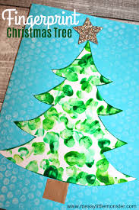  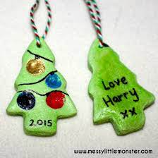  Christmas tree decoration
EAD - Music  Perform songs, rhymes, poems and stories with others, and (when appropriate) try to move in time with music. | Introduction to Nativity play | Learn Nativity songs in a group  Follow direction | Learn Nativity songs in a group  Follow direction | Learn Nativity songs in a group  Follow direction | Learn Nativity songs in a group  Follow direction | Rehearse Songs in a play | Perform to a live audience
EAD – DT  Understand healthy food choices and practice cooking and baking skills using their knowledge of healthy foods. |  |  | Make Diwali dish to experience different foods – chipattis and dahl? | Knowledge:  Children taste a range of foods and give their opinions  Children talk about which of the foods they will want to make based on what they enjoyed eating  Success Criteria  Children taste food and describe the flavours  Children make choices about what they’d like to make, thinking about healthy food choices | Knowledge:  Children are taught how to bake biscuits and have a go at practising these skills themselves  Success Criteria  Children follow instructions to bake biscuits  Knowledge:  Children begin to understand the origins of their food  Success Criteria  Children are able to talk about the ingredients they have used and that, for example butter is made from cows milk and flour is made from wheat grown in fields. | Knowledge:  Children talk about their baking experience, explain some of the techniques such as rolling and mixing  Success Criteria  Children talk about baking to others, describing what they did using words like mixing, sieving, pouring, rolling, baking | 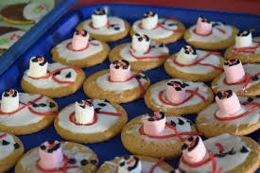
PE  Real PE Dance | Dance – Unit 1 | Dance – Unit 1 | Dance – Unit 1 | Dance – Unit 1 | Dance – Unit 1 | Dance – Unit 1 | Dance – Unit 1
UTW – Past and Present ‘Then and Now’  -Talk about the lives of the people around them and their roles in society.  - Know some similarities and differences between things in the past and now, drawing on their experiences and what has been read in class. | Comment on images of familiar situations in the past (Christmas, Old Toys and Nativity, ancient sanskrit characters Rama and Sita)  Compare and contrast characters from stories, including figures from the past (Jesus, Wee Wilie Winkie, Guy Fawkes, Santa, Rama Sita)
UTW (RE) - People & Communities  - Children talk about past and present events in their own lives and in the lives of  family members.  - They know that children don’t always enjoy the same things, and are sensitive to this.  - They know about similarities and differences between themselves and others, and  among families, communities and traditions | Talk about members of their immediate family and community. (Does everybody celebrate Christmas? Hanukkah and Diwali)  Understand that some places are special to members of their community (Church , Mosque, Temple)  Recognise some similarities and differences between life in this country and life in other countries (Diwali, Christmas in Australia)
UTW - Natural World | Explore the World around them- Autumn Seasons Walk around School Grounds and local area  Recognise some environments that are different from the one in which they live- Begin to introduce India as a Case study linked to our learning in Diwali  Describe what they see, hear and feel whilst outside: Bonfire Afternoon, exploring what they feel with a real bonfire (is there an area?)  Understand the effect of changing seasons on the natural world around them- Autumn Seasons links with previous term.

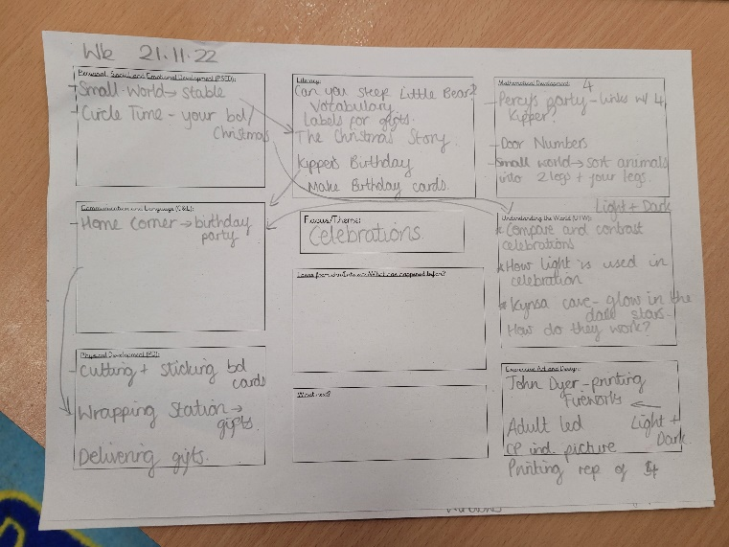
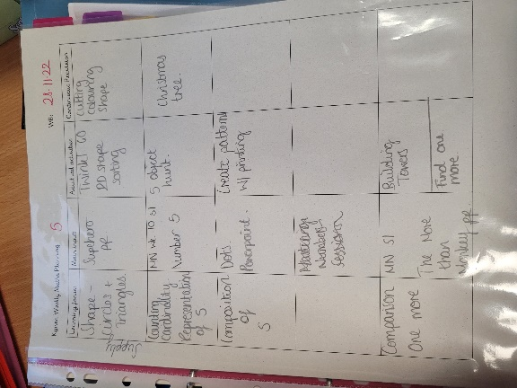
Weekly Planning with continuous provision:

Weekly maths planning:

We believe children are powerful learners and make progress with the right help. Therefore, a mix of different approaches are taken throughout the day dependent on the learning goal. This can be in the form of adult modelling during play, observing others during play, guided learning, direct teaching, and most importantly, learning through play with purposeful and meaningful continuous provision opportunities.

Assessment is utilised throughout the day. This is done through questioning, staff knowing the whole child, professional dialogue, photos, post-it notes, observations in the learning journey, physical evidence of work as well as running commentary on the class story on Class Dojo.

At Pendeen School, we know that relationships with parents is imperative to successful learning. Therefore, we utilise Class Dojo to communicate with parents by giving daily updates on learning, suggestions for activities to consolidate learning at home as well as personalized messages informing parents of their child’s progress. A member of staff is on the door at the beginning and end of the day as well as parents’ evenings throughout the year.

Impact
The experiences of learning will be revisited and demonstrated through being deeply engaged in play. Our children will grow to be confident, competent lifelong learners and good citizens.

The children at Pendeen experience a smooth transition between Nursery, Reception and beyond. Effective communication and collaboration ensure the children leave the EYFS with a solid foundation of learning of which to build upon.

We use a whole class learning journey memory book across the EYFS to document our learning. This is supplemented with a working wall within the classroom which celebrates children’s achievements. Exercise books are utilised within Reception when appropriate to the task, which evidence to the children and their families the successes of the children throughout their time in Early Years.

As a team, we carry out regular assessments and also ensure that staff attend external meetings and training to ensure that we feel confident with our judgements and that these judgements are consistent with a range of other settings. Assessment starts with careful observations which are then used to inform planning. Learning and teaching is thus effective when children feel a sense of belonging, curiosity and competence showing resilience and tenacity.

By monitoring assessment procedures regularly, we can effectively demonstrate what learning is taking place and how each child is progressing in all seven areas of the EYFS curriculum. Progress toward the ELGs will ensure a positive disposition to learn.

Year A | Autumn 1 | Autumn 2 | Spring 1 | Spring 2 | Summer 1 | Summer 2
EYFS | Ready, Steady, Go! | 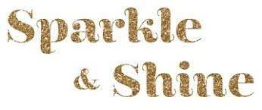  Sparkle and S hine | 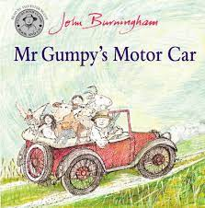  My Gumpy’s Travels | 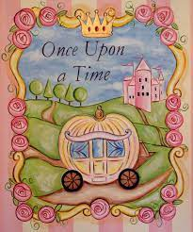  Once Up on a Time… | Kings and Queens  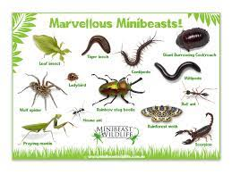  Minibeasts | 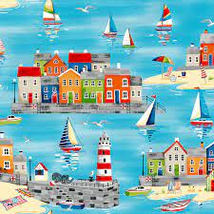  Beside the Sea
Resources for planning

Pendeen Sequencing Documents for EYFS

White Rose Reception Scheme of Work https://whiterosemaths.com/resources?year=early-years

Numbots – each child has their own login https://play.ttrockstars.com/numbots/dashboard

Nursery Rhymes - Nursery Rhymes and Songs - BBC Teach

RWI - Ruth Miskin School Portal

Oxford Owls - Dashboard

Music Charanga - Charanga

Real PE - Dashboard | real PE

