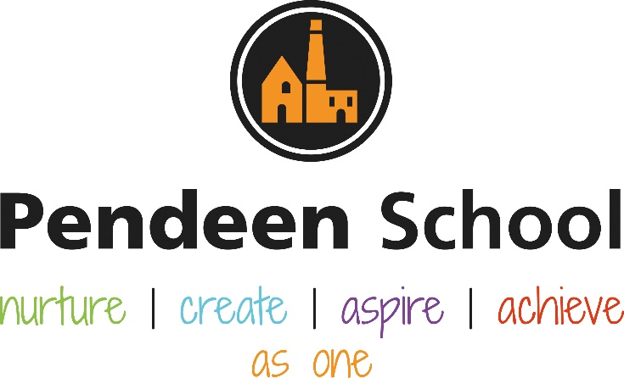

Design and Technology Guidance

Pendeen School Design & Technology Principles

Intent
The national curriculum for design and technology aims to ensure that all pupils:
♣ develop the creative, technical and practical expertise needed to perform everyday tasks confidently and to participate successfully in an increasingly technological world
♣ build and apply a repertoire of knowledge, understanding and skills in order to design and make high-quality prototypes and products for a wide range of users
♣ critique, evaluate and test their ideas and products and the work of others
♣ understand and apply the principles of nutrition and learn how to cook.
Key stage 1 Through a variety of creative and practical activities, pupils should be taught the knowledge, understanding and skills needed to engage in an iterative process of designing and making. They should work in a range of relevant contexts [for example, the home and school, gardens and playgrounds, the local community, industry and the wider environment]. When designing and making, pupils should be taught to: Design
♣ design purposeful, functional, appealing products for themselves and other users based on design criteria ♣ generate, develop, model and communicate their ideas through talking, drawing, templates, mock-ups and, where appropriate, information and communication technology Make
♣ select from and use a range of tools and equipment to perform practical tasks [for example, cutting, shaping, joining and finishing]
♣ select from and use a wide range of materials and components, including construction materials, textiles and ingredients, according to their characteristics
Evaluate
♣ explore and evaluate a range of existing products
♣ evaluate their ideas and products against design criteria Technical knowledge
♣ build structures, exploring how they can be made stronger, stiffer and more stable
♣ explore and use mechanisms [for example, levers, sliders, wheels and axles], in their products.

Key stage 2 Through a variety of creative and practical activities, pupils should be taught the knowledge, understanding and skills needed to engage in an iterative process of designing and making. They should work in a range of relevant contexts [for example, the home, school, leisure, culture, enterprise, industry and the wider environment]. When designing and making, pupils should be taught to:
Design
♣ use research and develop design criteria to inform the design of innovative, functional, appealing products that are fit for purpose, aimed at particular individuals or groups
♣ generate, develop, model and communicate their ideas through discussion, annotated sketches, cross-sectional and exploded diagrams, prototypes, pattern pieces and computer-aided design Make
♣ select from and use a wider range of tools and equipment to perform practical tasks [for example, cutting, shaping, joining and finishing], accurately
♣ select from and use a wider range of materials and components, including construction materials, textiles and ingredients, according to their functional properties and aesthetic qualities
Evaluate
♣ investigate and analyse a range of existing products
♣ evaluate their ideas and products against their own design criteria and consider the views of others to improve their work
♣ understand how key events and individuals in design and technology have helped shape the world Technical knowledge
♣ apply their understanding of how to strengthen, stiffen and reinforce more complex structures
♣ understand and use mechanical systems in their products [for example, gears, pulleys, cams, levers and linkages]
♣ understand and use electrical systems in their products [for example, series circuits incorporating switches, bulbs, buzzers and motors]
♣ apply their understanding of computing to program, monitor and control their products.

Cooking and nutrition As part of their work with food, pupils should be taught how to cook and apply the principles of nutrition and healthy eating. Instilling a love of cooking in pupils will also open a door to one of the great expressions of human creativity. Learning how to cook is a crucial life skill that enables pupils to feed themselves and others affordably and well, now and in later life. Pupils should be taught to:
Key stage 1
♣ use the basic principles of a healthy and varied diet to prepare dishes
♣ understand where food comes from.
Key stage 2
♣ understand and apply the principles of a healthy and varied diet
♣ prepare and cook a variety of predominantly savoury dishes using a range of cooking techniques
♣ understand seasonality, and know where and how a variety of ingredients are grown, reared, caught and processed.

At Pendeen School we ensure children are equipped with the skills to perform everyday tasks confidently participate successfully in an increasingly technological world.
We ensure children are taught essential skills for designing and making a product that can be used for a real purpose. We provide real experiences to ensure children can put their learning into context. Teachers plan creative and practical activities, with a clear skills progression across the school, providing children with the access to a range of opportunities where all children experience the full process of designing and making a product.

Implementation

The design & technology curriculum is planned in collaboration with all teachers at Pendeen school to ensure there is a clear skills progression.
Teachers ensure children have the opportunity to be creative thinkers where all children have the chance to design and invent.
Children are taught the necessary skills they may need for making a product, for example; cutting, shaping and finishing). These skills are then applied in making a product that the children see as purposeful and with an intention to use it.
Teachers plan design & technology lessons with events across the calendar in mind, for example sewing stockings at Christmas or baking biscuits for bake sale events.
All teachers plan design & technology lessons based around their topic and ensure the children get first hand experience of making their own product.
Children will have the opportunity to use our school 3D printer to build objects and items fit for a purpose (for example to make small car kits).
SHIP visits will monitor DT across the whole school working with local schools to carefully monitor and ensure skills are being taught effectively, lessons are well planned and delivered and children are making visible progress.
School governors will monitor the subject and have links into the classroom to work alongside not only the DT lead but each class teacher to observe DT lessons taking place.

Impact
Children talk with enjoyment about the subject.
Children can select the appropriate tools in order to make their product.
Children understand the purpose of making a product and can relate their product to a real life experience.
Children are equipped with successful skills for everyday life (such as understanding basic food hygiene and the ability to cut up different food).
Children will develop confidence and be willing to take risks.
All children will experience baking or cooking something to eat.
All children will produce a purposeful product that they can use in every day life.
D&T lead will monitor the teaching and learning of the subject and invite children to discuss and share their thoughts.
Teachers from Year 1 – Year 6 will add photographs of the children’s learning journey and final makes into their class floor book which will be assessed by both teachers and the DT lead.

Rolling Programme – Information for staff
Term | Area of Learning | Examples of creations
Autumn 1 | Autumn Basket making | 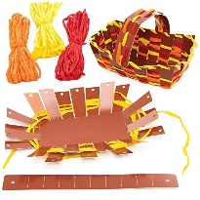
Autumn 2 | Christmas baking – edible gifts | 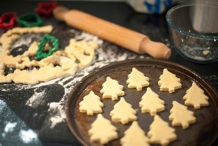  This Photo by Unknown Author is licensed under CC BY
Spring 1 | Modes of transport for class races | 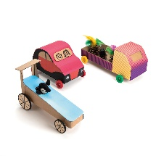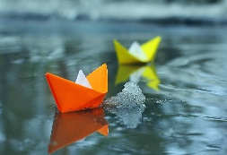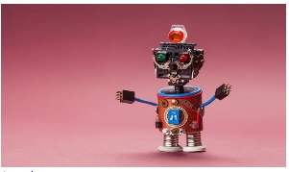  This Photo by Unknown Author is licensed under CC BY-ND  This Photo by Unknown Author is licensed under CC BY
Spring 2 | Easter biscuits / cupcakes / saffron buns  Healthy alternatives to traditional sweet treats | 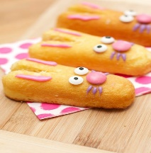  This Photo by Unknown Author is licensed under CC BY-SA-NC
Summer 1 | Lafrowda Day  Banner, flags and bunting making to decorate the outdoor of the school | 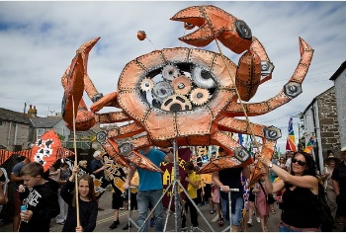
Summer 2 | Cornish Pasties / Afternoon Tea for the local community  Savoury: pasties and savoury scones | 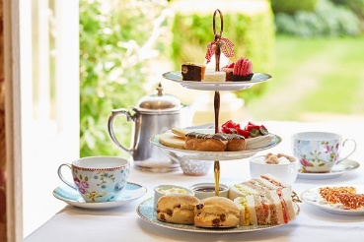

Rolling Programme – Information for parents
Term | Skill
Autumn 1 | select from and use a wider range of tools and equipment to perform practical tasks | Year A – children design and make an Autumnal basket for collecting leaves  Year B – EYFS and KS1 weave a spider web and KS2 weave a spider web themed basket  Children will first design their basket, use a range of appropriate tools to cut and weave the basket together and finally evaluate and use their basket for a purpose.
Autumn 2 | select from and use a wide range of ingredients, according to their characteristics | During the second Autumn term children will learn about locally sourced seasonal produce.  Children will design and make an edible gift to share with their family at the end of the term selecting appropriate ingredients.  Children will get the opportunity to look at, touch, taste and cook / bake with ingredients following a simple recipe.
Spring 1 | understand and use mechanical systems in products | Children will learn about ‘things that move’ and design and make their own moving resource. Children can choose whether they make a mode of transport to race with their friends or a moving resource such as a robot. Children will learn about how things move, the mechanisms needed in order to make these move, including forces and in KS2 children will learn how to use electricity for decorative and/or practical purposes.
Spring 2 | use the basic principles of a healthy and varied diet to prepare dishes | Children will learn the traditional foods made and eaten over the Easter period while learning how to recreate some of their favourite recipes using alternative healthy recipes. Each child will get the opportunity to design and make their own Easter treat and be able to recognise and understand the importance of a healthy, balanced diet.
Summer 1 | understand how key events and individuals in design and technology have helped shape the world | As we approach Summer children will have the opportunity to learn about local ‘makers’ who design and create for a purpose with an audience in mind. Children will have a go at making a decorative item for the school (colourful flags, bunting or banners) as well as working collaboratively to create something on a much larger scale to present at our local Lafrowda Day festival at the end of the Summer.
Summer 2 | prepare and cook a variety of predominantly savoury dishes using a range of cooking techniques | At the end of the year children will design a small menu based on using fresh local Cornish produce using traditional Cornish foods and share the food they make with our local community, inviting parents and families for a picnic on the school field with a ‘Cornish graze box’ that includes a Cornish pasty, scone and drink made by the children. Children will learn about their Cornish heritage and the history of food in Cornwall, specifically pasties enjoyed by miners at Geevor. We will work hard to collaborate and work with local businesses to make this experience a fantastic opportunity for our budding cooks and entrepreneurs.

Rolling Programme – Pictures for curriculum display
 | Year A Aut 1 | Year A Aut 2 | Year A Spring 1 | Year A Spring 2 | Year A Summer 1 | Year A Summer 2 | Year B Aut 1 | Year B Aut 2 | Year B Spring 1 | Year B Spring 2 | Year B Summer 1 | Year B Summer 2
EYFS | 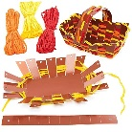 | 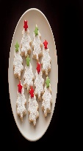  This Photo by Unknown Author is licensed under CC BY | 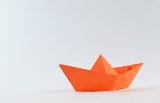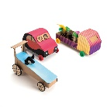 |  | 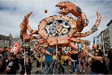 | 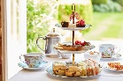 |  | This Photo by Unknown Author is licensed under CC BY  This Photo by Unknown Author is licensed under CC BY
KS1 |  | This Photo by Unknown Author is licensed under CC BY | 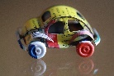
Lower KS2 |  | This Photo by Unknown Author is licensed under CC BY | This Photo by Unknown Author is licensed under CC BY |  |  |  | 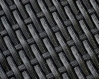 | This Photo by Unknown Author is licensed under CC BY | This Photo by Unknown Author is licensed under CC BY
Upper KS2 |  | 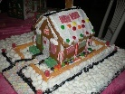 | 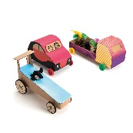 |  |  |  |  | This Photo by Unknown Author is licensed under CC BY-NC

Resources for planning

*At Pendeen School we encourage children to be themselves, to be creative, unique, celebrate their differences and recognise their own likes and dislikes which inform their designs and creations in DT lessons.
*At Pendeen Primary School our DT lead plans all projects using the National Curriculum as the key foundation, tailoring the curriculum to the interests and needs of the children within our school.
*Planning and resources are prepared and ready for all teachers to use, provided by the DT lead.
*School staff encourage children to be creative, unique and these traits are celebrated with confidence.
*All children will have the opportunity to learn how to use the school 3D printer.
*Each DT project is linked to either: key events of the year, religious events, seasonal festivals or traditions and the interests of the children.
*Every class teacher has a DT floorbook to document the journey and progress of every child in the whole school. Children can look back at theirs and others creations for inspiration for future makes.
*In EYFS we document the development of design and tecnology skills through observations uploaded to Target Tracker in each child’s learning journey.
*All children are assessed via Target Tracker by their class teacher.

Lesson Structure

We dedicate a block of time (one full day) at the end of every half term to Design and Technology learning. At Pendeen School we feel children have a rich and engaging experience with more motivation and sense of pride because children can fully immerse themselves into the design and creation of their final make. Children do not have to ‘stop / start’ their projects over several weeks and can spend a full day at a time engrossed in their project for a purpose.
Design and Technology becomes the focus of every staff member and learner at the end of each half term.
We incorporate local events, National events and key religious events into our learning where possible.
We encourage learning about our local heritage and link the history of Cornwall into some of the children’s creations (for example the Afternoon Tea party at the end of the year).
We celebrate and document learning through floorbooks and upload assessments from these into Target Tracker.

Presentation Convention
Every child from Year 1 to Year 6 has the opportunity to share their designs and photos of creations in their classroom floor book. Children in Reception have access to age appropriate tools and resources throughout each day in our Creative Area where children’s designs and makes are photographed for observation and assessment on Target Tracker.
Children’s creations are made for a purpose and displayed in classrooms until children have the opportunity to use their product and keep it (unless edible!).
We ensure every child has the opportunity to access floor books from their year group to support their current or future learning and build on existing learning. Children are reminded how they used certain tools or techniques to help them make informed decisions for future creations.
We welcome and encourage strong community links, inviting children’s families in for picnics to taste the food the children have made, attending local festival Lafrowda Day to display our whole school and individual creations for an audience in a parade, designing and making cars with the opportunity for parents to attend sessions for building together and watching each class race.

