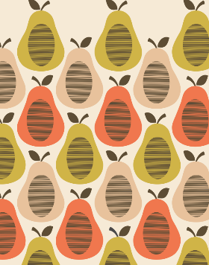
What is the full name of the famous designer who created this pattern?

What technique does this artwork involve?
Explain the steps you would take in order to create a repeated pattern using this skill using green and gold words:
1.
2.
3.
4.
5.

Explain how to create a Collograph print:
1.
2.
3.

Explain how to create a Hapazome print:
1.
2.
3.

Describe the key differences between a Collograph and Hapazome print:

