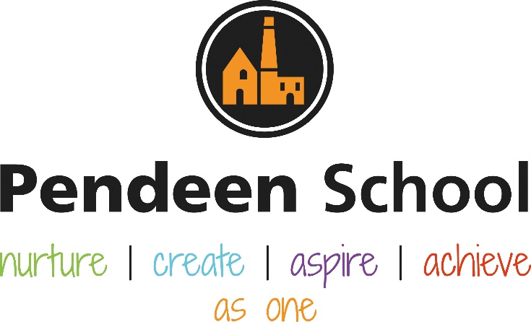

Geogpraphy Guidance

Pendeen School Geography Principles

Intent
At Pendeen School, we endeavour to provide learning opportunities to develop children’s knowledge and understanding of the world, environment and places near and far. Children will develop their substantive knowledge through:
- Locational knowledge – Position and directions
- Place knowledge – Locality and changes over time
- Human and Physical geography – exploring features of the locality as well as places across the world
- Geographical skills and fieldwork – applying their learning from above
- Map skills – being able to decipher maps, globes and atlases and decoding information as well as developing an understanding of aerial photography and satellite images such as use of Google Earth
Additionally, children will make connections across other subjects to explore sustainable development, cultural awareness and diversity across the world.

Implementation

EYFS will be more fluid and suited to the interests of the children make topics child led. The Rolling Programme below will be updated as the year goes on. There will be specific links to the local community and the world across Autumn and Spring, and comparing to other countries in the Summer.
KS1, LKS2 and UKS2 will follow the Rising Stars Voyager Scheme which suits the needs of our Pendeen children because covers all of the curriculum objectives from the programmes of study (PoS) in the National Curriculum. Units progress through the knowledge and skills outlined within the PoS, revisiting and consolidating learning where necessary. Teachers adapt planning to suit the needs of their class as well as adapting to suit our locality. All learning will be reflected within our geography memory books which can be used to revisit previous learning as well as provide a discussion point for the children. Additionally, it is expected for at least one piece of cross curricular writing from each unit.

Impact
The impact will be measured by children’s engagement with geography. Children will question because of curiosity which will be assessed through teacher assessment on Target Tracker and termly monitoring from geography lead to include discussion with children. Memory books will reflect children’s learning and a deep dive monitor will take place with partner SHIP schools.

Rolling Programme – Information for staff
 | Year A Aut 1 | Year A Aut 2 | Year A Spring 1 | Year A Spring 2 | Year A Summer 1 | Year A Summer 2 | Year B Aut 1 | Year B Aut 2 | Year B Spring 1 | Year B Spring 2 | Year B Summer 1 | Year B Summer 2
EYFS
KS1
Lower KS2
Upper KS2
Rolling Programme – Information for parents
 | Year A Aut 1 | Year A Aut 2 | Year A Spring 1 | Year A Spring 2 | Year A Summer 1 | Year A Summer 2 | Year B Aut 1 | Year B Aut 2 | Year B Spring 1 | Year B Spring 2 | Year B Summer 1 | Year B Summer 2
EYFS
KS1 | Physical GWhat |  | Human and Physical Geography Locational Knowledge Where does our food come from? |  | Geographical skills and fieldwork Locational Knowledge What are the 7 wonders of the world? |  | Place Knowledge What’s it like where we live? |  | Locational Knowledge What will we see on our journey around the world? |  | Locational Knowledge Where do different animals live?
Lower KS2
Upper KS2
Rolling Programme – Pictures for curriculum display
Year A | Autumn | Spring | Summer
EYFS | 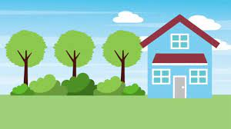  Where we live  -Links to the local community and learning about their own world around them.  - Topics will be child led with a focus on people, culture and communities | 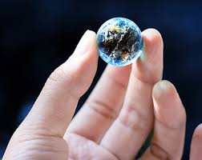  Our World  - Explore, observe the natural world  -Exploring children’s interests such as animals, marine life etc. | What’s different?  - Linking learning together by comparing similarities and differences.  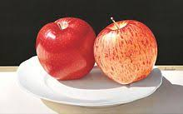  Topics will be child led with a focus on people, culture and communities.
KS1 | 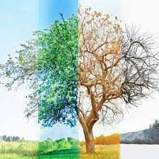  What are seasons? | 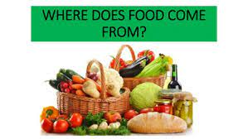  Where does our food come from? | 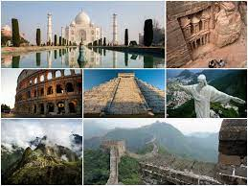  What are the 7 wonders of the world?
LKS2 |  | SPRING 2 Can the Earth Shake, rattle and roll? | SUMMER 1 Can you come on a great American road trip?  SUMMER 2 How does water go round a round?
UKS2 | 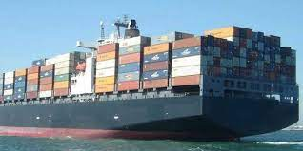  Where does all of our stuff come from? | Are we damaging our world?  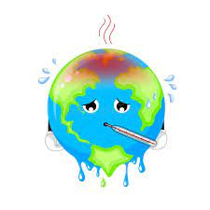 | 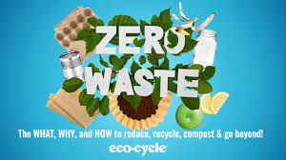  How will our world look in the future?

Year B | Autumn | Spring | Summer
EYFS | Where we live  -Links to the local community and learning about their own world around them.  - Topics will be child led with a focus on people, culture and communities | Our World  - Explore, observe the natural world  -Exploring children’s interests such as animals, marine life etc. | What’s different?  - Linking learning together by comparing similarities and differences.  Topics will be child led with a focus on people, culture and communities.
KS1 | What’s it like where we live?  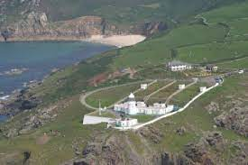 | 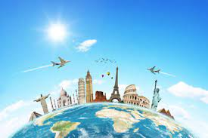  What will we see on our journey around the world? | 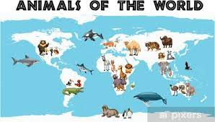  Where do different animals live?
LKS2 | AUTUMN 2 Where on earth are we? |  | SUMMER 1 Is climate cool?  SUMMER 2 Do you like to be beside the seaside?
UKS2 | How is our country changing?  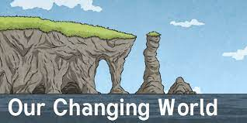 | 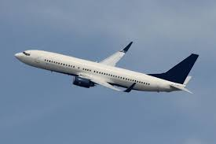  Where should we go on holiday? | 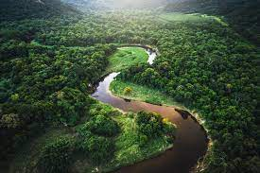  What is it like in the Amazon?
Resources for planning
- For KS1 and KS2, each class teacher has a copy of the relevant Voyagers Geography book. Resources for each lesson are provided online where each class teacher has their own login. Please see administrator should you have problems. https://www.risingstars-uk.com/login?returnurl=/my-account.aspx
- For EYFS, resources will be developed specifically to suit the children’s needs.

Lesson Structure

At the beginning of the geography lesson there will be a 2 minute spatial awareness activity to develop children’s vocabulary. For example, Which way will I go to get to the shop? To America?
Think like a geographer 5 minute recap of previous learning – this could be through questioning from Memory books, a quiz or hands on activity dependent on previous learning.
Main input will follow the structure of the Voyagers activities where teacher’s can adapt lesson to suit their needs. It is expected that teachers use the lesson objective and success criteria and ensure that all activities are within this criteria.

Working walls
When learning about a unit of learning, a working wall needs to reflect the current learning alongside vocabulary relevant to the unit. This can be built up over time. A picture can be taken at the end of the unit to be put in to memory books as a title page for the unit of learning.

Memory books
Each unit needs a title page to show the unit of learning – working wall picture will be added to this at the end of the unit. For assessment purposes, post its/ticket in the doors should be used to reflect children’s starting point. Post its/ticket out the doors should then be completed and then placed next to the starting point to show progress.
With each objective taught, memory books should be filled with useful resources for the children to revisit as well as examples of work. Each child must have at least one piece of work for each unit.

