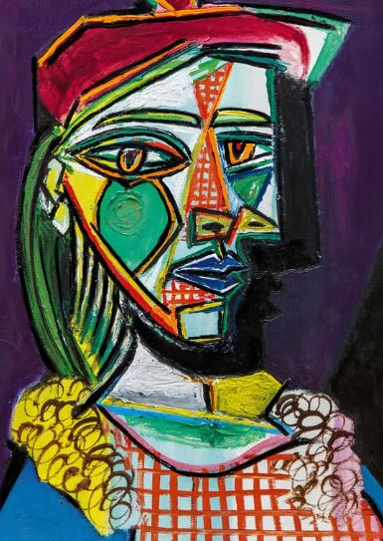

What is the full name of the artist who painted this picture?

Describe how you would alter a self portrait in order to achieve the ‘abstract’ effect?

Describe how colour can be used to alter emotion?

_______________________________________________________________________________________________

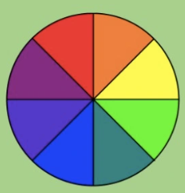
Describe how ‘opposite’ colours are used to change the appearance of a picture:

Explain how you would mix primary colours to make your own pallet of secondary colours?

