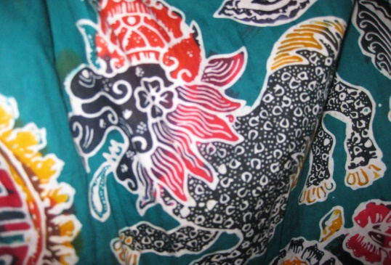
This Photo by Unknown Author is licensed under CC BY
- What is this technique called?

- What creates the patterns shown in the image above?

- What skills do you need for this technique:
1.
2.
3.

- List the resources (using technical names where appropriate) needed to produce this artwork:
1.
2.
3.
4.
5.
6.
7.

- What is the most important thing to remember when making this artwork?

- Explain how you could add detail to your artwork:

