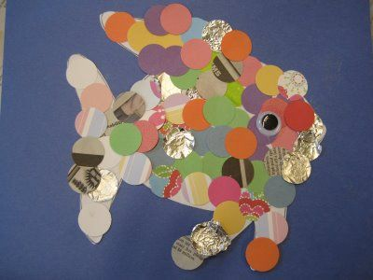
What is this type of artwork called?

Name an artist who creates this type of artwork:
Explain the steps necessary to complete this artwork:
1.
2.
3.
4.

Describe how you could change the composition of your image:

Explain how you could alter the perspective of the image using your green and gold words:

