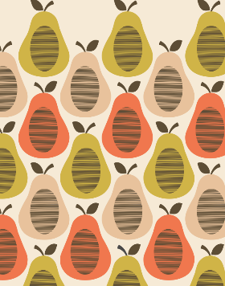
Which famous designer created this pattern?

What is special about these patterns?
What 2 things would you need to make this artwork:
1.
2.

How could you make your own version of this piece of art?

