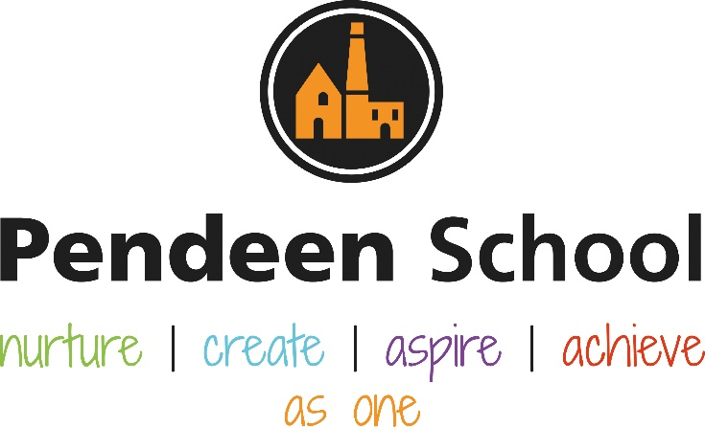

Music Guidance

Pendeen School Music Principles

Intent
At Pendeen School, we want our children to develop a love and passion for music which lasts for life. We’re passionate about children’s musical learning and it’s potential to help all children grow up as kind, curious, sensitive, and open-minded people. ‘For many pupils, the music they love will be part of the narrative of their lives and bring colour to the experiences that shape them’ Research review Series: music https://www.gov.uk/government/publications/research-review-series-music/research-review-series-music
We echo that ‘Music is a universal language that embodies one of the highest forms of creativity. A high-quality music education should engage and inspire pupils to develop a love of music and their talent as musicians, and so increase their self-confidence, creativity and sense of achievement.’ (Statutory guidance, National Curriculum in England: music programmes of study 2013).

Implementation
Pendeen School recognises the importance of music which is reflected through the way in which we deliver our music curruclum.
We utilise Charanga, an online platform, which provides coverage of the national curriculum through progressive week-by-week lessons. It champions Listening, Understanding, Composing, Improvising and Singing/Instrumental Performance which combines all 3 pillars of developing musical knowledge. The first being ‘technical development’ where children are able to translate their intentions successfully into sound through singing or instrumental playing. The second being ‘constructive’ where children gain an understanding of how musical components come together both analytically and in the creative process. The third being expressive which focuses of the more indefinable aspects of music: quality, meaning and creativity.

Each Unit of Work comprises the of strands of musical learning which correspond with the national curriculum for music:
- Listening and Appraising
- Musical Activities
  - Warm-up Games
  - Optional Flexible Games
  - Singing
  - Playing instruments
  - Improvisation
  - Composition
- Performing
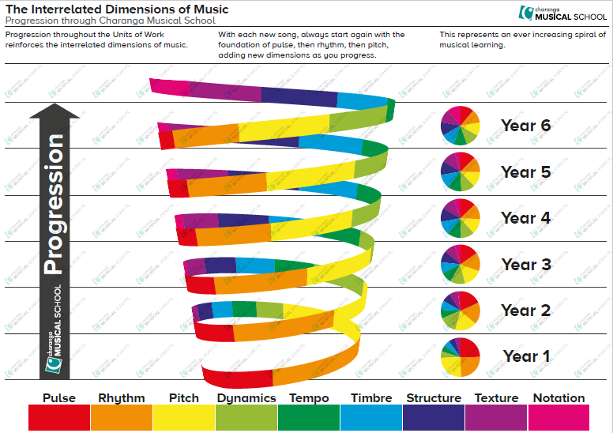
Progression is shown through the interrelated Dimensions of Music as shown in the screenshot to the right. Each unit of work is based around a song which has been selected to suit the age group of the children, as well as provide a diverse and wide variety of genres in order to provide our children with an experience with music which they may or may not have come across before. Our aim is to provide children with the opportunity to develop their love of a new genre or develop it even further and gain a greater understanding.

In addition to using Charanga as our scheme of learning, we also have KS1 and KS2 performances (Christmas and End of Year)
We take part in wider community events such as Yuletide Fayre, Carols with Animals, Lafrowda – this is throughout the year and subject to change depending on our community events.
- First Access delivered through a musical specialist where teacher’s can gain first hand CPD in the classroom environment as well alongside children developing instrumental skills.
- External music lessons – Singing, piano, drumming, and guitar

Impact
Termly monitoring through informal lesson observations, pupil conferencing with children, time with SHIP partners including a deep dive of the subject.
Feedback from performances and experiences.

Rolling Programme – Information for staff and parents
 | Year A Aut 1 | Year A Aut 2 | Year A Spring 1 | Year A Spring 2 | Year A Summer 1 | Year A Summer 2 | Year B Aut 1 | Year B Aut 2 | Year B Spring 1 | Year B Spring 2 | Year B Summer 1 | Year B Summer 2
EYFS
KS1
Lower KS2
Upper KS2
Rolling Programme – Pictures for curriculum display
Year A | Autumn 1 | Autumn 2 | Spring 1 | Spring 2 | Summer 1 | Summer 2
EYFS | Me! | Christmas performance | Everyone! | Our World | Big Bear Funk | Reflect,  Rewind  and Replay
KS1 | Hey You! | Christmas performance | In the Groove | 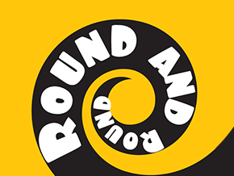  Round and Round | Your Imagination | Reflect,  Rewind  and Replay
LKS2 | Let your Spirit Fly | Christmas Carols | Three Little Birds | The Dragon Song | 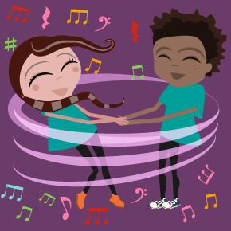  Bringing Us Together | Reflect,  Rewind  and Replay
UKS2 | Living On A Prayer  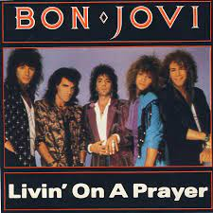 | Christmas Performance | 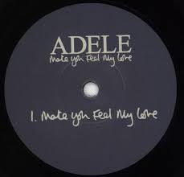  Make you feel my love | 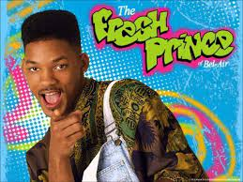  Fresh Prince of Bel-Air | 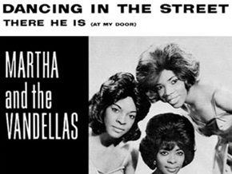  Dancing in the Street | Reflect,  Rewind  and Replay

Year B | Autumn 1 | Autumn 2 | Spring 1 | Spring 2 | Summer 1 | Summer 2
EYFS | Me! | Christmas performance | Everyone! | Our World | Big Bear Funk | Reflect,  Rewind  and Replay
KS1 | Hands, Feet, Heart | Christmas performance | I Wanna Play I A Band | 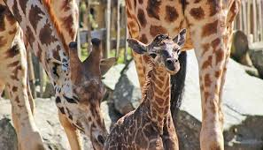  Zootime | 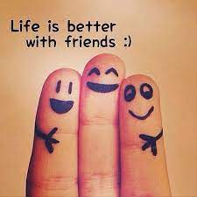  Friendship Song | Reflect,  Rewind  and Replay
LKS2 | Mamma Mia  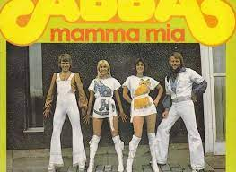 | Christmas Carols | Stop! | 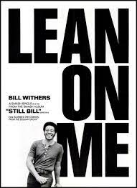  Lean On Me | 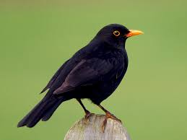  Blackbird | Reflect,  Rewind  and Replay
UKS2 | 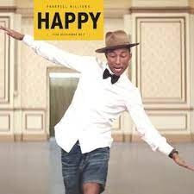  Happy | Christmas Carols | A New Year Carol | 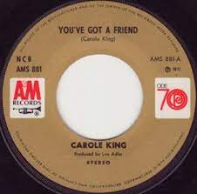  You’ve Got A Friend | Music and Me | Reflect,  Rewind  and Replay

Resources for planning
*We follow a rolling programme using Charanga - https://cornwall.charanga.com/scheme
Each teacher has their own username (may be a number) and password to access the scheme.
*Explanation of keywords used in step-by-step planning document are in Staff Share → music
*Cornwall Musical Education Hub (CMEH) providing First Access lessons and instruments.

Lesson Structure

Each Unit of Work comprises the of strands of musical learning which correspond with the national curriculum for music:
- Listening and Appraising
- Musical Activities
  - Warm-up Games
  - Optional Flexible Games
  - Singing
  - Playing instruments
  - Improvisation
  - Composition
- Performing
There will be a weekly music lesson of at least 45 minutes where the structured lesson will comprise of:
Listen and Appraise – 15 mins
Musical Activities – 20 mins
Perform/Share – 10 mins

Assessment guides can be used throughout. At the end of a Unit teacher’s will complete Target Tracker and classes shall share their learning with other classes to provide a meaningful context.

