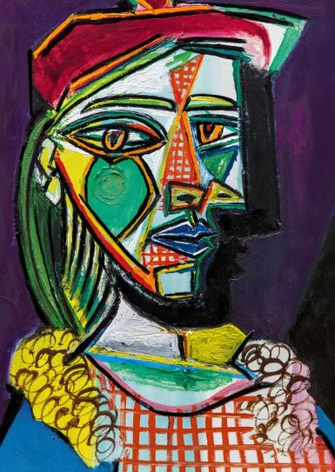

Which artist painted this picture?

Describe the term ‘abstract’ when referring to this style of artwork:

Describe how you could add emotion to a self portrait using either sketching or colour?

_______________________________________________________________________________________________

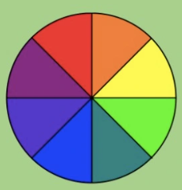
Cubism often uses opposite colours, explain how you could use opposite colours to create a Picasso style self portrait:

