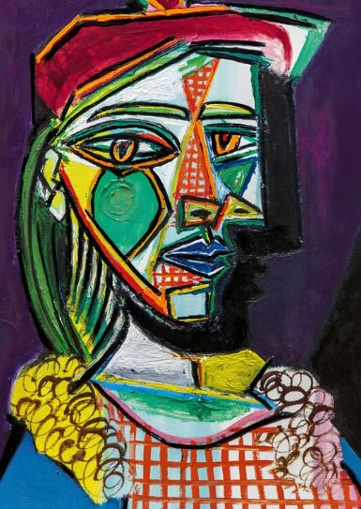

Which artist painted this picture?

Describe the term ‘abstract’ when referring to this style of artwork:

Which type of paint is best suited to create vibrant bright colours?

_______________________________________________________________________________________________

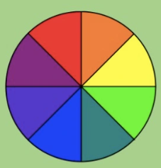 Using this colour wheel, which colours would you suggest are best used as ‘opposites’?

______________ and ______________

______________ and ______________

______________ and ______________

