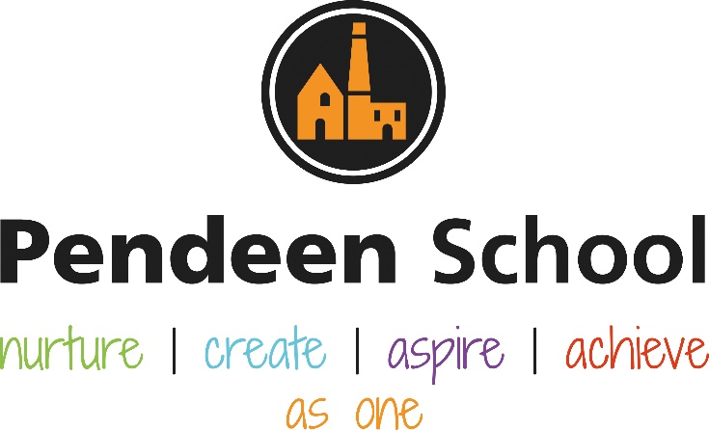

History Guidance

Pendeen School History Principles
A high-quality history education will help pupils gain a coherent knowledge and understanding of Britain’s past and that of the wider world. It should inspire pupils’ curiosity to know more about the past. Teaching should equip pupils to ask perceptive questions, think critically, weigh evidence, sift arguments, and develop perspective and judgement. History helps pupils to understand the complexity of people’s lives, the process of change, the diversity of societies and relationships between different groups, as well as their own identity and the challenges of their time.
Intent
To provide children at Pendeen with a high-quality curriculum, which works alongside the National curriculum, following our long-term planning document.
To provide real meaningful learning opportunities.
To enable children to have a sound understanding of local, national and world history.
To understand how history has impacted us in our local community, within in the country we live and the wider world.
To provide children with the opportunities to meet with people who have lived through historical events.
To enable children to take part in community remembrance services/celebrations, (Levant Mine disaster, Lafrowda Day)
For children to understand how evidence is used to understand the past and how we can use this to further our knowledge.
To provide children with trips to enhance their learning and provide real learning opportunities, (Geevor to study rocks, Porthcurno Telegraph Museum to look at telecommunications).
To ensure all children are adequately supported avoiding over scaffolding and to implement retrieval practice to support long term knowledge.
To provide opportunities for children to build on prior knowledge and to anticipate common misconceptions.
To provide good quality fiction and non-fiction books to support the teaching of history across all key stages, especially EYFS
To provide exploration and discovery time through well resourced learning areas in the EYFS classroom

Implementation
History will be taught either weekly, or as a group of lessons depending on the topic and learning opportunities for that topic.
History is taught for three half terms over the academic year, with the alternative terms being Geography, teachers can choose which terms to teach the subjects
Adults will provide real learning opportunities to hook the children’s engagement within the topic.
To provide children the opportunities to visit local places of interest, and for people to visit the school with local historical knowledge.
To provide resources that will enable children to investigate and enquire about events.
To allow children where ever possible to take part in local history events, through art, music, drama poetry etc.
To have strong links with local feeder schools enabling children to work alongside other teachers and children to take part in historical lessons.
Children will have access to programmes like BBC Bitesize and Newsround to enable them to keep up with current affairs in the world.
Resources will be from reliable websites, book stores to provide children with good quality resources.
Children will be taught a strong chronology of events to allow a build up of a ‘mental timeline’ of the past.
Children’s knowledge will be assessed at the start of the topic through questioning, quizzes and the chance for children to record their current knowledge.
Children in EYFS will have the chance to explore and answer questions through well resourced play areas inside and outside the classroom.
Children with SEND will be supported at Pendeen to meet their full potential, setting high expectations for their learning.
Children needs will be met by following APDRs that may be in place, providing specialist writing equipment for children with Dyspraxia for example.
All staff will work closely with outside professional agencies to meet all children’s needs so no child is left behind.

Impact
Children will be fully engaged in all the activities that we offer at Pendeen
Children will work on projects outside of the school day, and will take part in out of school activities through the school and other local groups
Children will have a better understanding of the world around them and ask enquiring questions
Children will be able to articulate their thoughts and discuss evidence that they have researched
Children will be able to come to their own conclusions on the evidence that they have sourced, and discuss their reasoning coherently
Children will have a strong chronology of the past, which can be used in a learning context both in History and across other subjects.
SHIP days will allow for discussion with other head teachers and the subject lead, looking at memory books, discussion with children and other staff. This will take place in the second term of the academic year.
Subject lead will have the opportunity to talk with children across the key stages and to carry out a book scrutiny in the memory books. This will take place once a term in discussion with the class teacher for a suitable time to not interrupt learning within the class.
Time will be made available once a term for a lesson observation timetabled to fit in with the history teaching for that term.
A pre-discussed focus with the teacher will be observed throughout the lesson, this could be a focus on the chronology of learning for that year group, building on prior learning.
Children’s knowledge will be assessed at the start of the topic through questioning, quizzes and the chance for children to record their current knowledge.
Lead Governor of History (Mrs Squires) will meet with subject lead to monitor learning and progress through in school visits, meeting with children and book reviews.

Rolling Programme information for staff
YEAR B | EYFS | KS1 | LOWER KS2 | UPPER KS2
AUT UMN 1 | 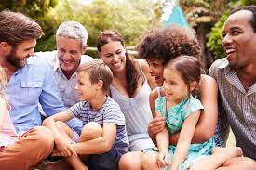  Talk about the lives of the people around them and their role in society |  | 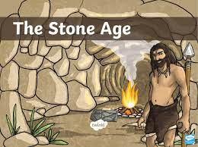  Unit 1: What was new about the new Stone Age? | Unit 1: What impact did the Anglo-Saxons have?  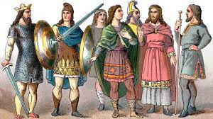
AUTUMN 2 | Talk about the lives of the people around them and their role in society | 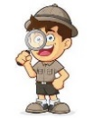  Unit 6: Who were the great explorers?
SPRING 1 | 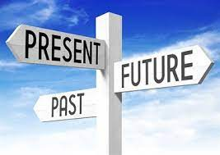  Know some similarities and differences between things in the past and now |  | 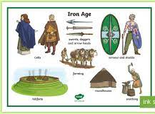  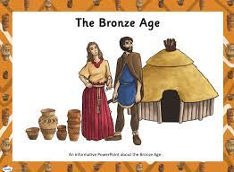  Unit 2: How unpleasant was the Bronze and Iron Ages? | Unit 2: Would the Vikings do anything for money?  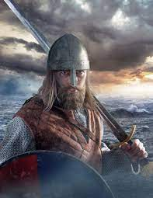
SPRING 2 | Know some similarities and differences between things in the past and now | 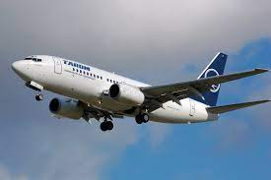  Unit 4: How did the first flight change the world? | Unit 3: How much did the Ancient Egyptians achieve?  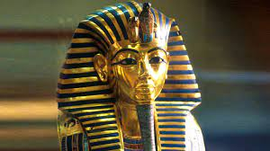
SUMMER 1 | Understand the past through settings, characters and events through story telling |  |  | Unit 3: Why should we remember the Maya?  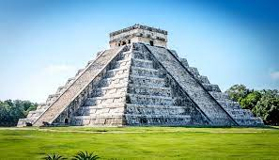
SUMMER 2 | Understand the past through settings, characters and events through story telling | Unit 5: How has food changed over time?  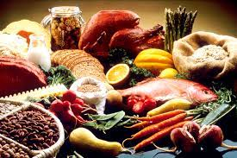
Rolling Programme information for staff
YEAR A | EYFS | KS1 | LOWER KS2 | UPPER KS2
AUT UMN 1 | Talk about the lives of the people around them and their role in society |  | Unit 4: What happened when the Romans came?  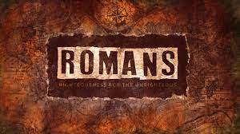 | Unit 4: How did World War II impact our local area?  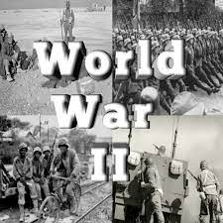
AUTUMN 2 | Talk about the lives of the people around them and their role in society | 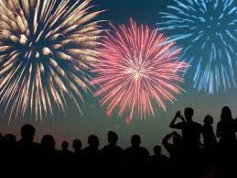  Unit 3: Why do we remember the fifth of November | Unit 5: What was important to our local Victorians?  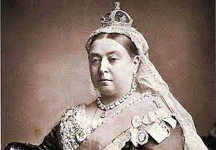
SPRING 1 | Know some similarities and differences between things in the past and now |  | 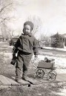  Unit 6: Is it better to be a child now than in the past? | Unit 5: Why should we thank the Ancient Greeks?  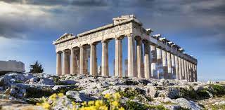
SPRING 2 | Know some similarities and differences between things in the past and now | 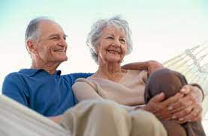  Unit 1: What was life like when our grandparents were children?
SUMMER 1 | Understand the past through settings, characters and events through story telling | Unit 2: Who are our local heroes? |  | Unit 6: How has communication changed over time?
SUMMER 2 | Understand the past through settings, characters and events through story telling

Rolling Programme information for parents
YEAR A | EYFS | KS1 | LOWER KS2 | UPPER KS2
AUT UMN 1 | Talk about the lives of the people around them and their role in society |  | Unit 1: What was new about the new Stone Age? | Unit 1: What impact did the Anglo-Saxons have?
AUTUMN 2 | Talk about the lives of the people around them and their role in society | Unit 6: Who were the great explorers?
SPRING 1 | Know some similarities and differences between things in the past and now |  | Unit 2: How unpleasant was the Bronze and Iron Ages? | Unit 2: Would the Vikings do anything for money?
SPRING 2 | Know some similarities and differences between things in the past and now | Unit 4: How did the first flight change the world? | Unit 3: How much did the Ancient Egyptians achieve?
SUMMER 1 | Understand the past through settings, characters and events through story telling |  |  | Unit 3: Why should we remember the Maya?
SUMMER 2 | Understand the past through settings, characters and events through story telling | Unit 5: How has food changed over time?
Rolling Programme information for parents
YEAR B | EYFS | KS1 | LOWER KS2 | UPPER KS2
AUT UMN 1 | Talk about the lives of the people around them and their role in society |  | Unit 4: What happened when the Romans came? | Unit 4: How did World War II impact our local area?
AUTUMN 2 | Talk about the lives of the people around them and their role in society | Unit 3: Why do we remember the fifth of November | Unit 5: What was important to our local Victorians?
SPRING 1 | Know some similarities and differences between things in the past and now |  | Unit 6: Is it better to be a child now than in the past? | Unit 5: Why should we thank the Ancient Greeks?
SPRING 2 | Know some similarities and differences between things in the past and now | Unit 1: What was life like when our grandparents were children?
SUMMER 1 | Understand the past through settings, characters and events through story telling | Unit 2: Who are our local heroes? |  | Unit 6: How has communication changed over time?
SUMMER 2 | Understand the past through settings, characters and events through story telling

Rolling Programme information for display
YEAR A | EYFS | KS1 | LOWER KS2 | UPPER KS2
AUT UMN 1 | Talk about the lives of the people around them and their role in society |  | Unit 1: What was new about the new Stone Age? | Unit 1: What impact did the Anglo-Saxons have?
AUTUMN 2 | Talk about the lives of the people around them and their role in society | Unit 6: Who were the great explorers?
SPRING 1 | Know some similarities and differences between things in the past and now |  | Unit 2: How unpleasant was the Bronze and Iron Ages? | Unit 2: Would the Vikings do anything for money?
SPRING 2 | Know some similarities and differences between things in the past and now | Unit 4: How did the first flight change the world? | Unit 3: How much did the Ancient Egyptians achieve?
SUMMER 1 | Understand the past through settings, characters and events through story telling |  |  | Unit 3: Why should we remember the Maya?
SUMMER 2 | Understand the past through settings, characters and events through story telling | Unit 5: How has food changed over time?
Rolling Programme information for display
YEAR B | EYFS | KS1 | LOWER KS2 | UPPER KS2
AUT UMN 1 | Talk about the lives of the people around them and their role in society |  | Unit 4: What happened when the Romans came? | Unit 4: How did World War II impact our local area?
AUTUMN 2 | Talk about the lives of the people around them and their role in society | Unit 3: Why do we remember the fifth of November | Unit 5: What was important to our local Victorians?
SPRING 1 | Know some similarities and differences between things in the past and now |  | Unit 6: Is it better to be a child now than in the past? | Unit 5: Why should we thank the Ancient Greeks?
SPRING 2 | Know some similarities and differences between things in the past and now | Unit 1: What was life like when our grandparents were children?
SUMMER 1 | Understand the past through settings, characters and events through story telling | Unit 2: Who are our local heroes? |  | Unit 6: How has communication changed over time?
SUMMER 2 | Understand the past through settings, characters and events through story telling

Resources for Planning
*We follow the rolling programme to insure coverage and content is appropriate for age and stage across mixed age classes.
*We use Rising Stars to support our rolling programme covering one unit per term. All teaching staff have their own individual login details
https://www.risingstars-uk.com/
* We use BBC Bitesize to engage and encourage questioning, oracy and thinking about historical debate.
https://www.bbc.co.uk/bitesize

Lesson Structure

Staff have the discretion when they teach History, depending on the topic and content coverage
The majority of our lessons are practical and immersive
All written work is to a high standard
We complete hot and cold questioning to assess knowledge at the beginning and end of the term

Presentation Convention

Each class has a History working wall it should display vocabulary, examples of children’s thinking and learning (this could be post it notes)
WAGOLL for the history writing
Memory Books will require current learning to be added across the topic
Vocabulary to be displayed on the working wall and the memory books
Examples of children’s learning on the working wall
Photograph at the year group at the start of the academic year, with topic title and term date

