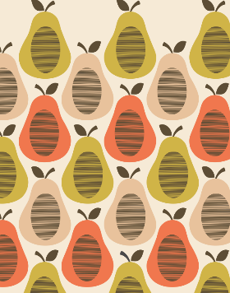
What is the full name of the famous designer who created this pattern?

What technique does this artwork involve?
Explain the steps you would take in order to create a repeated pattern using this skill:
1.
2.
3.
4.
5.

Describe the process of making this artwork using your green and gold words:
1.
2.
3.
4.

Explain how to use ink rollers in order to print:
1.
2.
3.

Explain the difference between mono printing and block printing:

