Newsletter 35 03/05/23

Dear Parents and Children,

I hope everyone had a good weekend – it has lovely to hear of trips to the beach and sea swimming.

Strike Days and Bank Holidays – There are no further strike days planned at present and I will let you know as soon as possible if this changes. There is only one further Bank Holiday in school term time - school will be closed to all children on Monday 8th May.

St. Michael’s Mount Feedback – A message from Kerry, the Education Leader on the Mount following the Kynsa and Nessa Trip last week – “I wanted to send a quick email to you to say what a fantastic day we’ve had with your children and staff.
The children were all impeccably behaved with fantastic manners and plenty of relevant questions.”
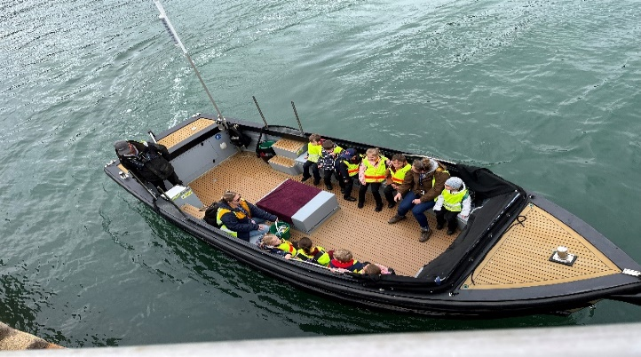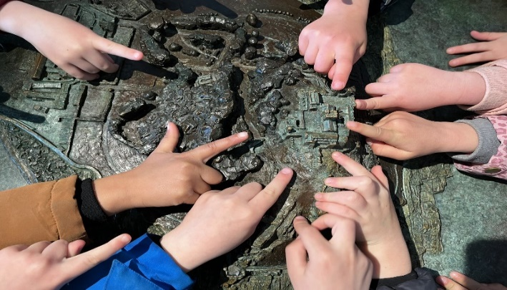
Year 6 transition days – Cape Cornwall – 21st and 22nd June with a parents event after school on the 22nd. More details to follow when we have them.

Coronation Event – 5th May 2023 - Please collect your child/children from their usual pick up point at 1:15pm on Friday 5th May 2023. Your child will be in your care from this point on. Any children who have not been collected will be supervised by a member of staff until you arrive or pick up at the end of the day. Please see Mrs Earley or Mrs Sharma, who will be situated by the field gate, if collecting your child after the designated time above.
Children will be sent home with an empty paper plate to fill with their sweet or savoury treat for our buffet. Please bring these in the morning of 5th May. Any containers will need to be clearly labelled.
On the day, children do not need to bring book bags to school but should dress as King, Queen or a creative combination! Alternatively, wear red, white and blue or Cornish colours.
Please donate any unused DVDs or CDs to Bo Duke for her stall to raise money for library books.
To help ensure safety and security, the entrance gate to the school will be shut during the event. Toilets access for all will be the public toilets in the car park opposite the field.
The garden party will finish at normal pick up time 3:15pm, ending with a water fight.
There will be no after school clubs on this day. Wrap around care for those children who are booked in will continue as normal.

Year 6 SATS and SATS Breakfasts – The year 6 children have been working hard and have their SATS tests next week. We will be running delicious breakfast sessions from 8.00am for all year 6 children next week and will be collecting the children’s choices tomorrow – crepes, juice, fruit, bacon rolls, cereal, bagels, cream cheese, smoked salmon etc!

Have a lovely week and fingers crossed for the weather.
Chris Wilson

