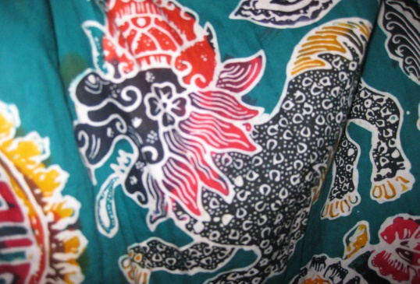
This Photo by Unknown Author is licensed under CC BY
- What is this technique called?

- What skills do you need for this technique:
1.
2.
3.

- What are 4 resources needed to produce this artwork:
1.
2.
3.
4.

- Tell me how each resource above is used:
1.
2.
3.
4.

- What is the name of the artist you’ve learnt about this half term?

- How could you recreate one of her pieces of art?

