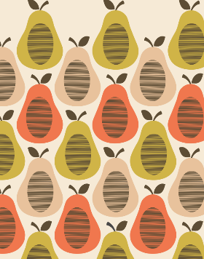
What is the full name of the famous designer who created this pattern?

What are the differences between Orla Kiely’s printing style and John Dyers printing style?
Explain how to create a Collograph print:
1.
2.
3.

Explain how to create a Hapazome print:
1.
2.
3.

Describe the key differences between a Collograph and Hapazome print:

Using your green and gold words explain how you would use either of these techniques to create a repeated pattern:

