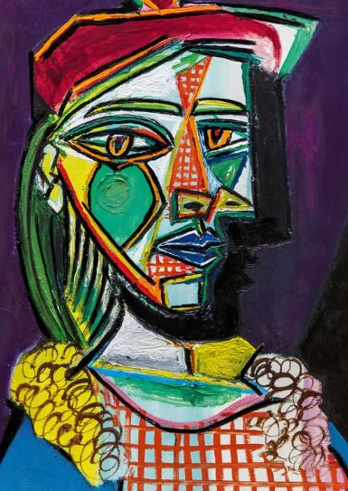
Which artist painted this picture?

What is different about a self portrait in this style?

There are 3 colours we mix to make new colours. These are called primary colours. What are they?
1.
2.
3.

Which 2 colours are mixed to make:

Purple _______ + __________

Orange _______ + __________

How can you make a colour darker?

How can you make a colour lighter?

