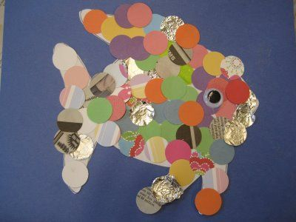
What is this type of artwork called?

Name an artist who creates this type of artwork:
Explain, using your green and gold words how you would create this image:
1.
2.
3.
4.
5.

Describe how you could change the composition of your image using different materials:

Explain how you could alter the texture of your image:

Explain how you would enhance the image by using more refined skills related to collage:

