**Pendeen Values**

**British Values**

**Human Values**

**Be kind; treat others how you want to be treated yourself.**

**Pendeen Vision, Values and Ethos**

At Pendeen School, we value the wellbeing and safety of the children in our care above all else. We provide a nurturing, creative and inspiring learning environment in which every child is given the best possible opportunity to reach their potential.  
We know our families exceptionally well and will always go the extra mile to nurture each member of the school community, enabling everyone to feel safe, secure and valued.  
We foster a positive and inclusive learning environment where children and staff are encouraged to be **creative**, **innovative** and **take risks** in all that they do.  
All children are recognised and valued as individuals with unlimited potential to **achieve**.  
As one, we work to create an open, welcoming school that is at the centre of our wonderful community.

**Our school aims to give every child the opportunity to develop:**

* A love of life and learning.
* Positive relationships with others.
* The skills and knowledge to achieve their highest potential.
* Resilience, resourcefulness and self-belief.
* A willingness to engage with new ideas and experiences.
* Respect and curiosity about the world around them.
* Courage, determination, flexibility and integrity.

***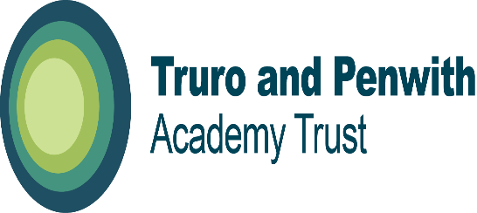*TPAT vision and values**

**“We believe all children and young people should have the best possible life chances and we do this with a relentless drive for the highest possible level of achievement involving academic, creative, sporting and cultural opportunities. “**

* recognise and encourage local distinctiveness and individuality
* inspire our Academies to become beacons of hope and aspiration in the communities they serve
* focus on improving learning and teaching for all – to enable all children and young people to have the best possible learning experience, leading to the highest levels of achievement
* work in partnership with the One Cornwall Teaching School and our associates to provide bespoke support and improvement activities of the highest quality in our Academies
* work with our Academies to facilitate partnership working and enable all staff to receive high quality development opportunities
* build on Truro and Penwith College’s example in high quality leadership and governance and benefit from the expertise of the College to promote excellence in all aspects of education
* support our Academies to be financially sustainable and retain a reserve
* acknowledge the diverse nature of the communities our Academies serve and encourage their full engagement in helping local Academies achieve outstanding outcomes for their students
* be an employer of choice – valuing the skills, contribution and expertise of all employees

**Pendeen Can!**

**CARE, ASPIRE, NUTURE**

Pendeen School instils the belief:

**Pendeen CAN**!

This is underpinned by a shared view that:

* We all have a right to feel safe.
* We all have a right to be treated with respect and dignity.
* We all have a right to equal opportunities.
* We all have a right to learn.

At Pendeen, we CAN be **Caring** towards ourselves and others. We CAN **Aspire** to be the best that we can be. We CAN **Nurture** ourselves and others to achieve our highest potential and look after ourselves and others.

* **Excellence** - particularly good work/effort, striving to do your best
* **Politeness** - displaying good manners, putting others first
* **Co-operation** – working with others, friendship, caring, kindness, happiness
* **Determination** - Staying on task, challenge, growth, patience, resilience
* **Courage** – taking risks and going out of your comfort zone
* **Assertiveness** – being able to communicate effectively, knowing when and how to communicate in different and appropriate ways
* **Responsibility** – taking ownership, moral, family, community
* **Honesty** – Fairness, saying sorry
* **Respect** – Diversity, listening, understanding, tolerance

|  |  |  |  |
| --- | --- | --- | --- |
| Pendeen Can Star Assemblies, British Values, PSHE and Achievement Assemblies | | | |
|  | PENDEEN CAN STAR FOCUS | Additional | Books |
| Autumn 1 | **Politeness**  **Excellence** | European Day of Languages 26/09/22  Black History Event 10/10/22 | Salt in His Shoes – Michael Jordon  Nadia, the Girl who Couldn’t Sit Still – Karlin Gray  Ish – Peter Reynolds |
| Autumn 2 | **Co-operation**  **Courage** | World Science Day 10/11/22  Remembrance Day 11/11/22  Children in Need 18/11/22  Christmas performances 13 and 14/12/22 | What do you do with a problem – Kobi Yamada  Jabari Jumps – Gaia Cornwall  After the Fall – Dan Santat  The Magical Yet – Angela DiTerlizzi  A Whistle for Willie – Ezra Jack Keats |
| Spring 1 | **Responsibility** | Word Religion Day 13/01/23  Safer Internet Day 23/01/23 | The Most Magnificent Thing – Ashley Spires  Flight School – Lita Judge  Beautiful Oops – Barney Saltzberg |
| Spring 2 | **Determination**  **Assertiveness** | World Book Day 02/03/23  St. Piran’s Day 03/03/23 | The Girl Who Never Makes Mistakes – Mark Pett  What do you do with an Idea – Yobi Kamada  Hana Hashimoto The 6th Violin – Chieri Uegaki  How to Catch a Star – Oliver Jeffers |
| Summer 1 | **Honesty** | World Downs Syndrome Day 21/03/23  World Poetry Day 21/03/23 | The Book of Mistakes – Corinna Luyken  The OK Book – Amy Krouse Rosenthal  When Sophie Thinks She Can’t – Molly Bang  Thanks for the Feedback, I Think – Julia Cook |
| Summer 2 | **Respect** | Trip to London 19/07/23 | Emmanuel’s Dream – Laurie Ann Thompson  Rosie Revere, Engineer – Andrea Beaty  The Dot – Peter Reynolds |

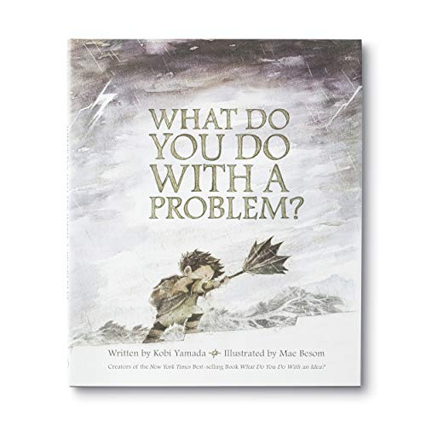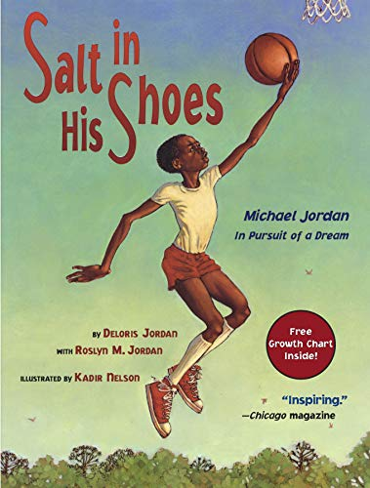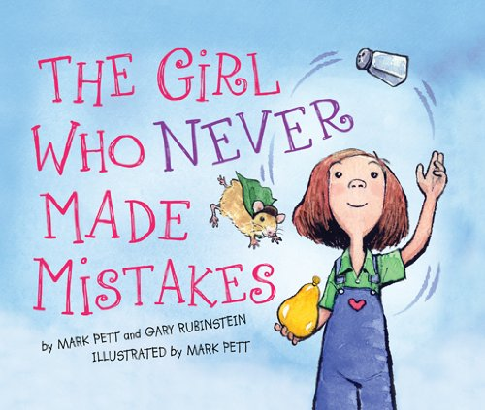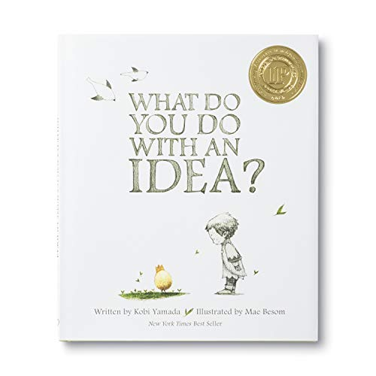

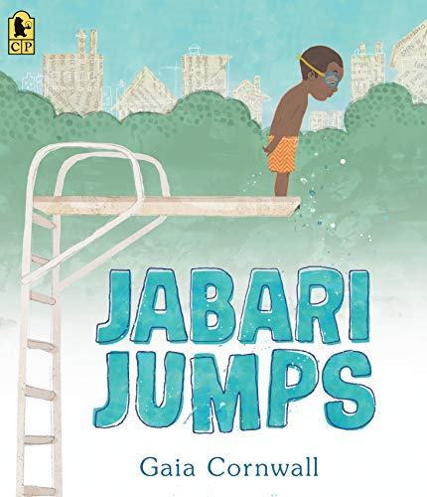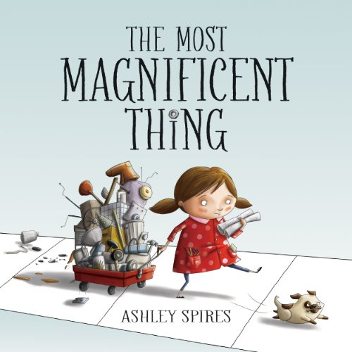

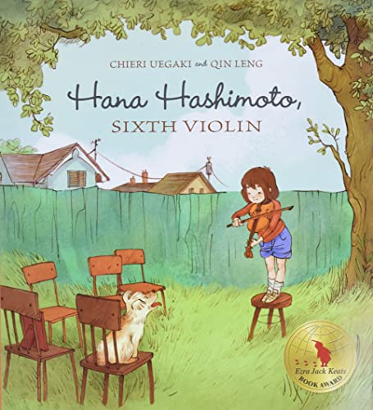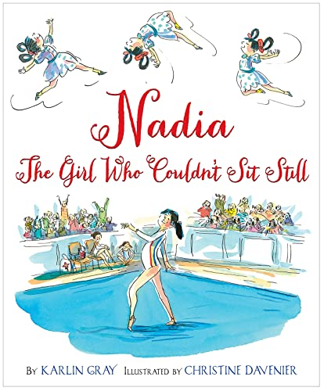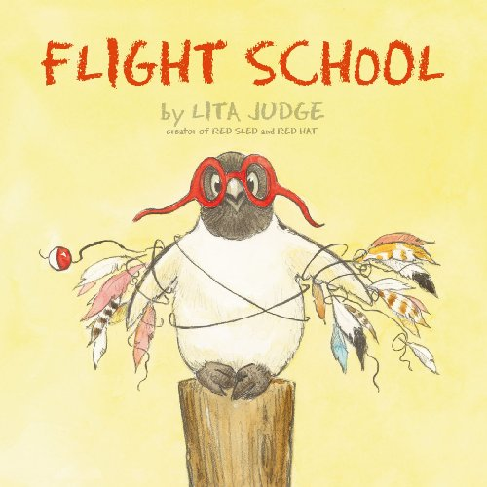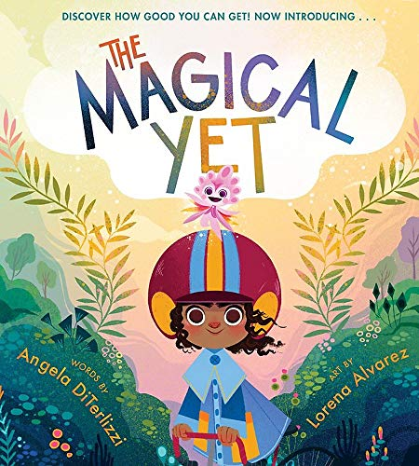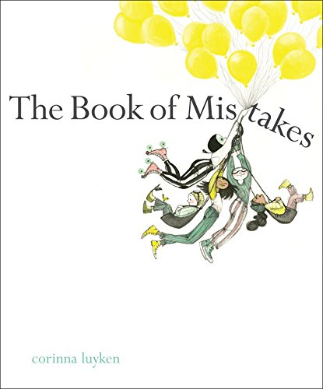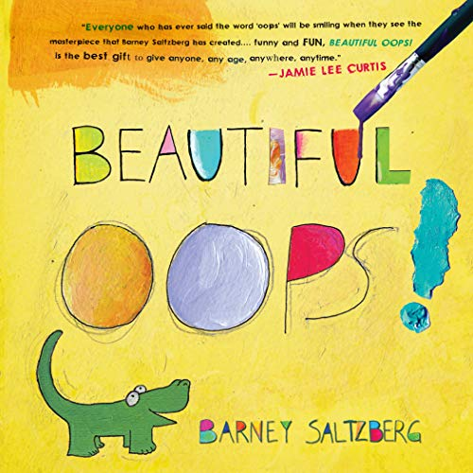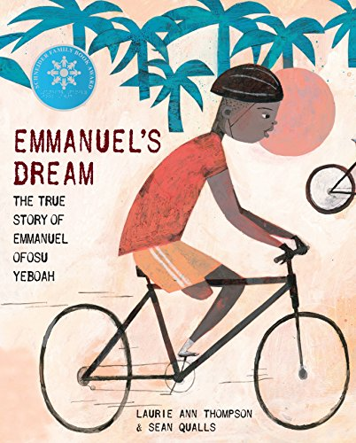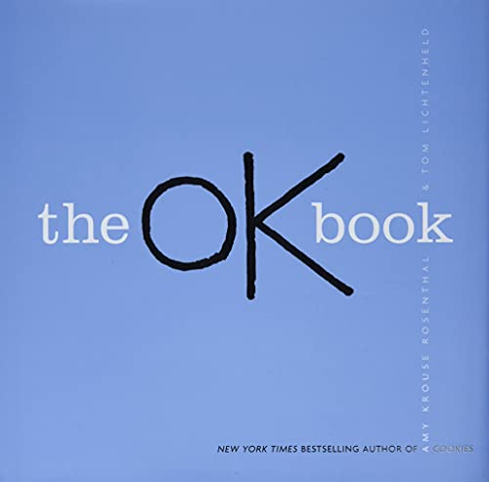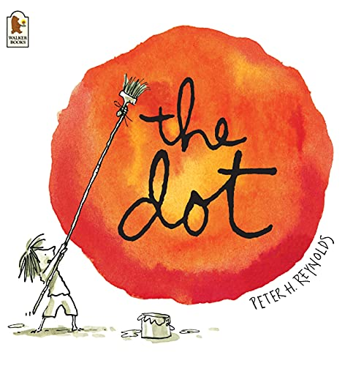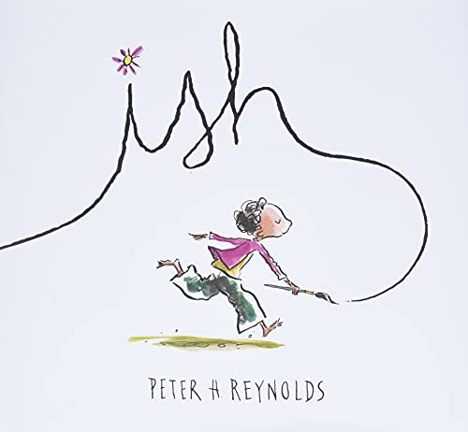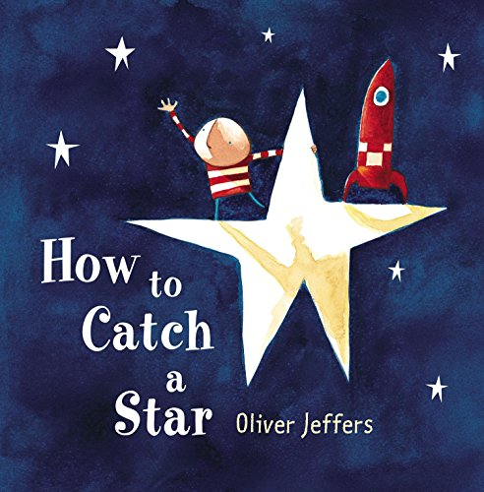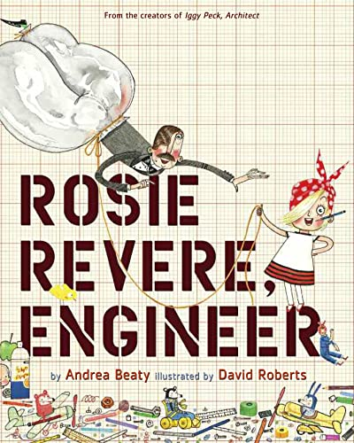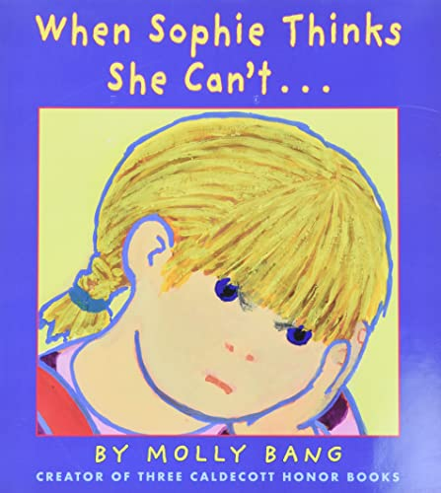

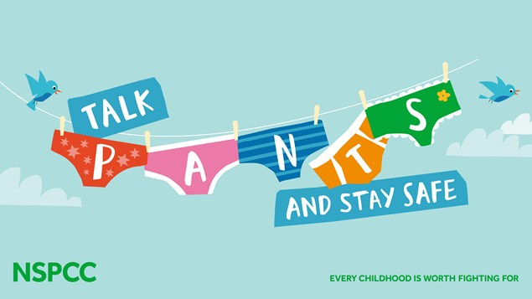**Privates are private**

**Always remember your body belongs to you**

**No means no**

**Talk about secrets that upset you**

**Speak up someone can help**

**We all have rights and responsibilities for ourselves and to others**

**We have the right to feel safe all of the time**

**Healthy relationships feel safe and comfortable**

**It’s important to remember that you always have a right to say no even when you have already said yes**

**If others don’t actually say no it doesn’t mean they are saying yes**

**Protected Characteristics**

**No-one can discriminate or be mean to you or anyone else because of your:**

Age

disability

race including colour

nationality

ethnic or national origin

religion or belief

sex

sexual orientation

**Tell Mr Wilson, an adult or your mentor if anyone is ever mean to you**

**E-Safety (24/01/23)**



