Pendeen UNDERSTANDING THE WORLD SCOPE, CONTENT and SEQUENCING EYFS

Year Group:  R | Half term: Autumn 1 | SCOPE: Ready, Steady, Go | CONTENT / INTENT:  DFE: Development Matters document. One page document for Early Learning Goals: https://content.twinkl.co.uk/resource/b1/55/tf-pa-2548620-eyfs-elg-one-page-document_ver_1.pdf?__token__=exp=1669644088~acl=%2Fresource%2Fb1%2F55%2Ftf-pa-2548620-eyfs-elg-one-page-document_ver_1.pdf%2A~hmac=2bbf36cc7cbac60bf927b2e214eb90730af058da55bbe4b97f0a4f684fedc31c
Prior Learning |  |  |  | Future Learning
Books/Stories
TTS – Owl Babies
Vocabulary: on, over, under, before, next, after, then, now, rules, gentle, kind, property, listen, work hard, honest, learning, excited, celebrate, ‘Never give up’, Autumn, harvest, safe, History, explore, investigate, outdoor areas, Library, Quiet Garden, Stable, Poly Tunnel, Trim Trail, Calm, peaceful, claves, Beat, Fred talk, word

Pendeen UNDERSTANDING THE WORLD SCOPE, CONTENT and SEQUENCING EYFS

Year Group:  R | Half term: Autumn 2 |  |  | SCOPE: Sparkle and Shine | CONTENT / INTENT:  DFE: Development Matters document. One page document for Early Learning Goals: https://content.twinkl.co.uk/resource/b1/55/tf-pa-2548620-eyfs-elg-one-page-document_ver_1.pdf?__token__=exp=1669644088~acl=%2Fresource%2Fb1%2F55%2Ftf-pa-2548620-eyfs-elg-one-page-document_ver_1.pdf%2A~hmac=2bbf36cc7cbac60bf927b2e214eb90730af058da55bbe4b97f0a4f684fedc31c
Prior Learning  Links to own celebrations – past birthdays and Christmas’s  Some experience of fireworks  Links to their past experiences | 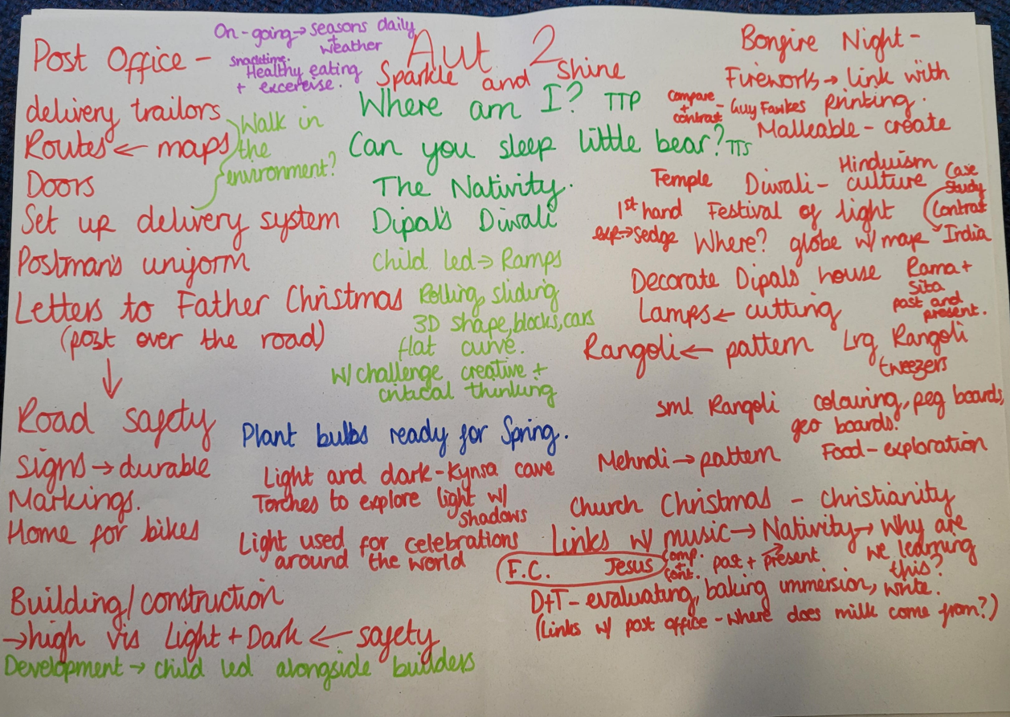 |  |  |  |  | Future Learning
Know the differences between a map, plan and aerial photograph
Use locational and directional language to describe locations on a map
Understand connections between cultural history and how this affects people’s daily lives.
Know differences and similarities between ways of life
Make sense of range of religious beliefs
Understand impact of significant individual
Make connections
between religious and non-religious beliefs, concepts, practices and ideas
Identify and name variety of everyday materials
Describe simple properties
Observe changes across the four seasons
Observe and describe weather associated with the seasons and how day lengths varies.

Books/Stories
PT – What am I?
TTS – Can you Sleep Little Bear?
TTS – The Christmas Story

Texts link to celebrations –
Dipal’s Diwali, Kipper’s Birthday, Scarecrows Wedding,

Vocabulary: Celebration, Nativity, Bonfire, Fireworks, Diwali, Culture, Faith , Religion, Remembrance, Wedding, Birthday, party, invitation, thank you letters, presents, vicar, church, tradition, slide, roll, curved, straight, part, whole,
Pendeen UNDERSTANDING THE WORLD SCOPE, CONTENT and SEQUENCING EYFS

Year Group:  R |  | Half term: Spring 1 | SCOPE: Mr Gumpy’s Travels |  | CONTENT / INTENT:  DFE: Development Matters document. One page document for Early Learning Goals: https://content.twinkl.co.uk/resource/b1/55/tf-pa-2548620-eyfs-elg-one-page-document_ver_1.pdf?__token__=exp=1669644088~acl=%2Fresource%2Fb1%2F55%2Ftf-pa-2548620-eyfs-elg-one-page-document_ver_1.pdf%2A~hmac=2bbf36cc7cbac60bf927b2e214eb90730af058da55bbe4b97f0a4f684fedc31c
Prior Learning:  Knowledge of Autumn – seasons  Understanding of local environment  Some knowledge of transport vehicles linked to own experiences |  | 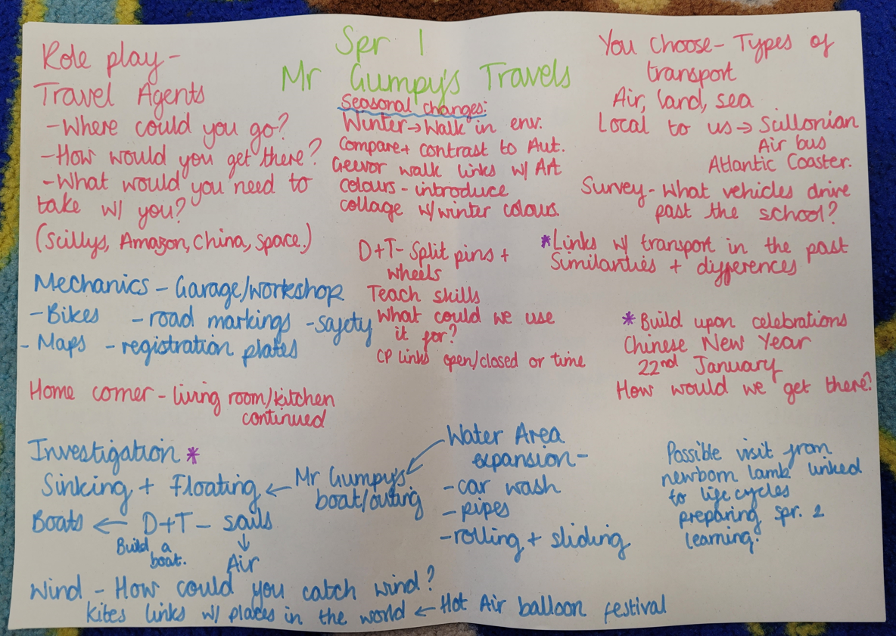 |  |  |  | Future Learning
Know the differences between a map, plan and aerial photograph
Use locational and directional language to describe locations on a map
Understand connections between cultural history and how this affects people’s daily lives.
Know differences and similarities between ways of life
Make sense of range of religious beliefs
Understand impact of significant individual
Make connections
between religious and non-religious beliefs, concepts, practices and ideas
Observe changes across the four seasons
Observe and describe weather associated with the seasons and how day lengths varies.
Use simple fieldwork
Develop knowledge about locality
Recognise human and physical features
Name and locate 7 continents and 5 oceans
Learn about non-European country
Use images, maps, atlases
Know differences and similarities between ways of life
Compare aspects of life in different periods
Understand historical concepts of change
Identify and name variety of everyday materials
Describe simple properties
Books/Stories:
TTS – One Snowy Night
TTS - Mr Gumpy’s Motor Car
PT - I’ve got a cold

Texts linked to transport – You choose, non-fiction plus revisiting Kynsa’s favourite stories, Paddington Goes to London
Vocabulary: push, pull, float, sink, heavy, light, full, empty, transport, winter, wind, rain, snow, Hail, Frost, Cloud, Sun, hear, hot, cold, warm, freezing, boiling, ice, melting fog, stormy, lightening, thunder, journey, ticket, train, bus, tram, boat, cruise ship, sailing boat, Scillonian, Aeroplane, airbus, land, sea, wind, sail, sailing boat, jungle, rainforest, nocturnal, space, sun, planet, meteorites, satellites, moon, homes, house, flat, apartment, canal boat, caravan, Chinese New Year, Celebration,

Pendeen UNDERSTANDING THE WORLD SCOPE, CONTENT and SEQUENCING EYFS

Year Group:  R | Half term: Spring 2 | SCOPE: Once Upon A Time | CONTENT / INTENT:  DFE: Development Matters document. One page document for Early Learning Goals: https://content.twinkl.co.uk/resource/b1/55/tf-pa-2548620-eyfs-elg-one-page-document_ver_1.pdf?__token__=exp=1669644088~acl=%2Fresource%2Fb1%2F55%2Ftf-pa-2548620-eyfs-elg-one-page-document_ver_1.pdf%2A~hmac=2bbf36cc7cbac60bf927b2e214eb90730af058da55bbe4b97f0a4f684fedc31c
Prior Learning  Experience of repetitive stories  Experience of traditional tales  Experience of Nursery Rhymes  Links to seasons – chn will know what Autumn and Winter  Experience of different celebrations and cultures | 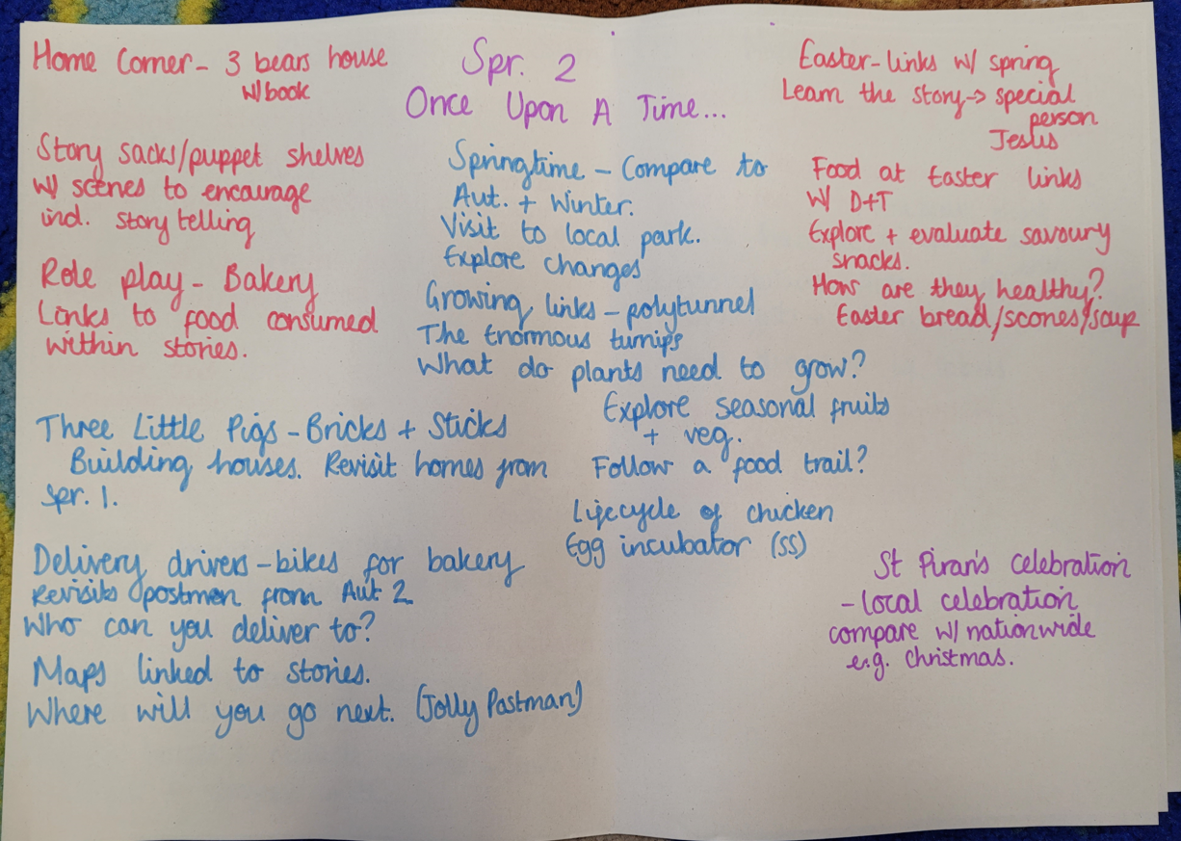 |  |  | Future Learning
Understand connections between cultural history and how this affects people’s daily lives.
Know differences and similarities between ways of life
Make sense of range of religious beliefs
Understand impact of significant individual
Make connections
between religious and non-religious beliefs, concepts, practices and ideas
Observe changes across the four seasons
Observe and describe weather associated with the seasons and how day lengths varies.
Use simple fieldwork
Develop knowledge about locality
Identify and name a variety of common wild and garden plants, including deciduous and evergreen trees
understand simple life cycles.
Books/Stories
TTS – The Gingerbread Man
TTS – Three Little Pigs

Texts linked to fairy tales w/ story sacks: Little Red Riding Hood, Jack and the Beanstalk, Cat and the Town Mouse, Princess and the Pea, Cinderella, Sleeping Beauty.

Vocabulary: Traditional tale, fairy tale, Once Upon A Time, Happily Ever After, Vocab. from The Gingerbread Man – ‘You can’t catch me, I’m the gingerbread man!’ etc. Vocab. from Three Little Pigs – ‘Not by the hair of my chinny, chin chin’ and ‘I’ll huff and I’ll puff and I’ll blow your house in’ etc, Spring, Spring Time, Lifecycle, deciduous tree, evergreen tree, growing, plants, roots, stem, seeds, germinate, life, hatching, health, vitamin, farming, produce, flowers, poly tunnel, seasonal fruit, seasonal vegetable, water, sun, air (oxygen), egg, chick, chicken, habitat, birth, child, adult, elderly, Homes, bricks, sticks, straw, map, positional language (forward, backward, straight, behind, in front, next to, left, right)

Pendeen UNDERSTANDING THE WORLD SCOPE, CONTENT and SEQUENCING EYFS

Year Group:  R | Half term: Summer 1 | SCOPE: Kings and Queens/ Minibeasts | CONTENT / INTENT:  DFE: Development Matters document. One page document for Early Learning Goals: https://content.twinkl.co.uk/resource/b1/55/tf-pa-2548620-eyfs-elg-one-page-document_ver_1.pdf?__token__=exp=1669644088~acl=%2Fresource%2Fb1%2F55%2Ftf-pa-2548620-eyfs-elg-one-page-document_ver_1.pdf%2A~hmac=2bbf36cc7cbac60bf927b2e214eb90730af058da55bbe4b97f0a4f684fedc31c
Prior Learning  Links to their past experiences - e.g. Queen’s Jubilee celebrations  Experience of animals in local environment such as sea gulls, worms, caterpillars etc | 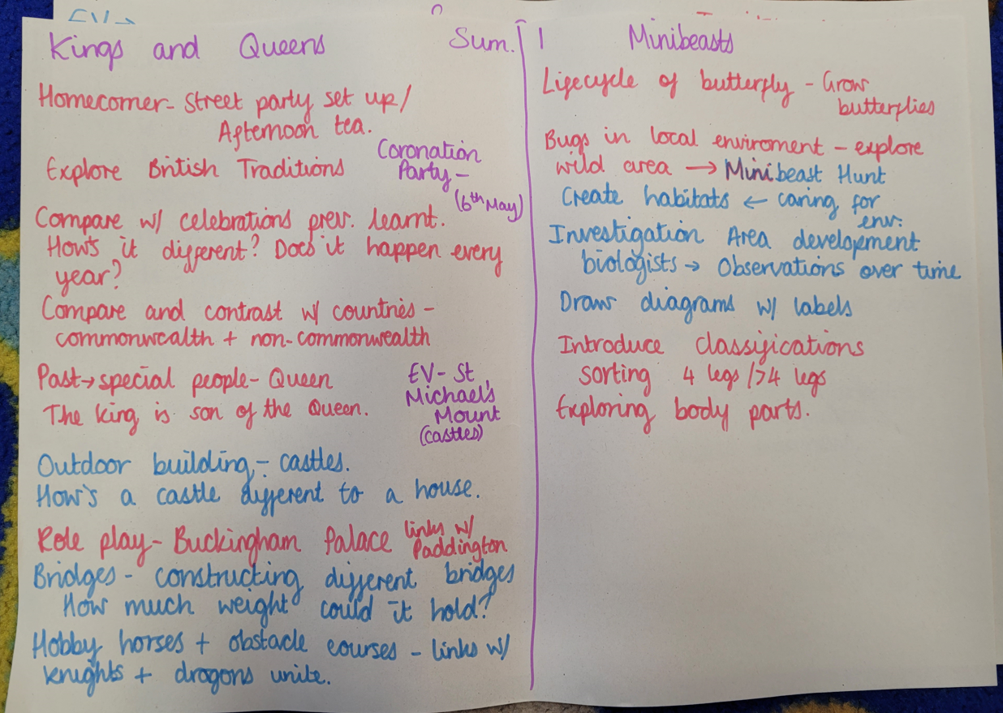 |  |  | Future Learning
Learn about the lives of significant individuals in the past who have contributed to national and international achievements,
know where people and events fit within chronological order,
Identify and name a variety of common animals including fish, amphibians, reptiles, birds and mammals,
Describe and compare the structure of a variety of common animals,
Understand connections between cultural history and how this affects people’s daily lives.
Know differences and similarities between ways of life
Understand impact of significant individual
Observe changes across the four seasons
Observe and describe weather associated with the seasons and how day lengths varies.
Use simple fieldwork
Develop knowledge about locality
Identify and name a variety of common wild and garden plants, including deciduous and evergreen trees
understand simple life cycles.

Books/Stories
TTS – Paddington at the Palace
PT – Pussy Cat, Pussy Cat
TTS – Cottonwool Colin
PT - Zanzibar

Texts linked within topics: Knight and Dragons Unite, I want my potty, Princess Smartypants
Hungry Caterpillar, What the Ladybird Heard, Spinderella
Vocabulary: King, Queen, Prince, Princess, Coronation, throne, castle, turret, palace, bridge, over, under, obstacle course, crown, decoration, celebration, commonwealth, prime minister, president, St Michael’s Mount, knight, dragon,
Refer back to Spring 1 vocab., caterpillars, butterflies, bee, pollination, cycle, incubation. Chrysalis, offspring, minibeast, habitat, grouping, classify, vertebrate, invertebrate, worm, spiders, moths, insects, ladybirds, body part, investigation, biologist, magnifying glass, label, diagram,

Pendeen UNDERSTANDING THE WORLD SCOPE, CONTENT and SEQUENCING EYFS

Year Group:  R | Half term: Summer 2 | SCOPE: Beside the Seaside | CONTENT / INTENT:  DFE: Development Matters document. One page document for Early Learning Goals: https://content.twinkl.co.uk/resource/b1/55/tf-pa-2548620-eyfs-elg-one-page-document_ver_1.pdf?__token__=exp=1669644088~acl=%2Fresource%2Fb1%2F55%2Ftf-pa-2548620-eyfs-elg-one-page-document_ver_1.pdf%2A~hmac=2bbf36cc7cbac60bf927b2e214eb90730af058da55bbe4b97f0a4f684fedc31c
Prior Learning  Some experience of the beach  The sea can be seen from the classroom  Walks in the local environment  Links back to minibeast in Summer 1 and group | 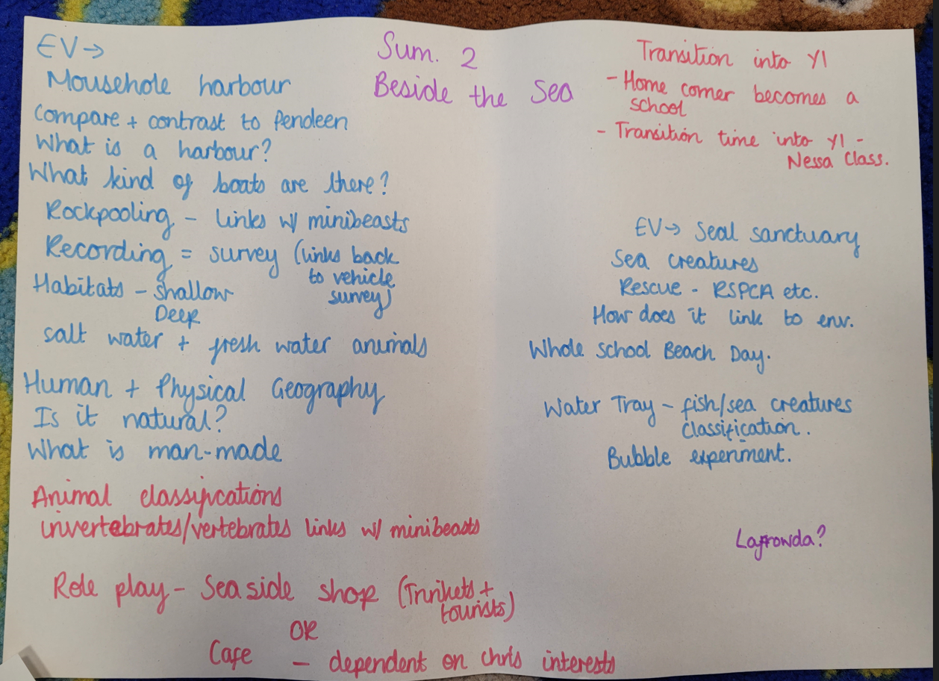 |  |  | Future Learning
Identify and name a variety of common animals including fish, amphibians, reptiles, birds and mammals,
Describe and compare the structure of a variety of common animals,
Observe changes across the four seasons
Observe and describe weather associated with the seasons and how day lengths varies.
Use simple fieldwork
Develop knowledge about locality
Use locational and directional language and to describe the location and features and routes on a map, use basic geographical vocabulary,
learn about human and physical geography in a small area,
Identify and name a variety of common wild and garden plants, including deciduous and evergreen trees
understand simple life cycles.
Identify, name, draw and label the basic parts of the human body and say which part of the body is associated with each sense,

Books/Stories:
TTS – Tiddler
TTS – The Rainbow Fish
PT – Oh, Oh, The Storyman

Texts linked to the seaside – Non-fiction, The Undersea Cleaning Spree, The Lighthouse Keeper, The Mousehole Cat

Vocabulary: rockpool, sea creature, crab, lobster, fish, pilchard, mackerel, hermit crab, net, bucket, spade, observation, care, environment, harbour, boats, sail, fishing boat, trawler, row boat, sea, sea water, Mousehole, beach, man-made, natural, Seal Sanctuary, rescue, seal, penguin, habitat, classify, continent, country, weather, Summer, Sun, Heat, Heatwave, sunhat, suncream, hydrate, beach safety, human geography – shop, path, road, wall, harbour, physical geography – hill, sea, coast, beach, sand, rock, rockpool, land

