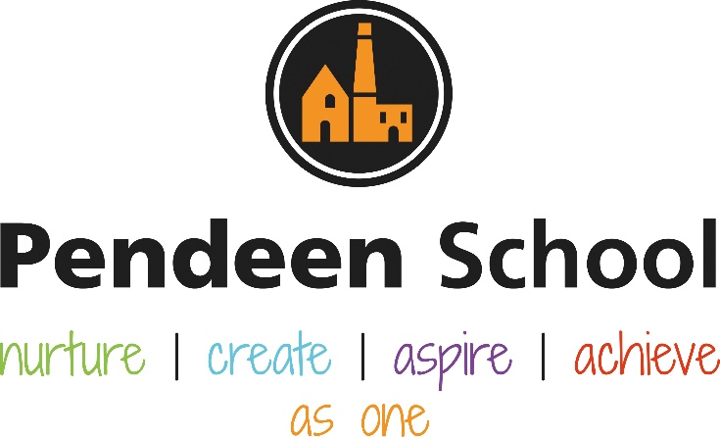

RE
Planning

Guidance for Staff

Pendeen School RE Principles

Intent
At Pendeen, we know the every pupil has an entitlement to religious education (RE).
We understand that RE is a necessary part of a ‘broad and balanced curriculum’ and must be provided for all registered pupils in state-funded schools in England unless withdrawn by their parents
Although this requirement does not apply for children below compulsory school age we will follow the Cornwall agreed syllabus in EYFS
We will provide as many “real” experiences through visits and visitors as possible.
As stated in the Cornwall agreed syllabus, we believe that the principal aim of religious education is to explore what people believe and what difference this makes to how they live, so that pupils can gain the knowledge, understanding and skills needed to handle questions raised by religion and belief, reflecting on their own ideas and ways of living. This fits within our ethos as stated in our SDP – At Pendeen School, we nurture each member of the school community, enabling everyone to feel safe, secure and valued. We foster a positive and inclusive learning environment where children and staff are encouraged to practise creativity in all that they do.
Through our curriculum, we encourage each child to aspire to discover and cultivate their character qualities, skills and interests.
At Pendeen, all children are recognised and valued as individuals with unlimited potential to achieve.
As one, we work to create an open, welcoming school that is at the centre of the community.
All children follow the Cornwall Agreed Syllabus and all staff and children understand that RE contributes dynamically to children and young people’s education in schools by provoking challenging questions about meaning and purpose in life, beliefs about God, ultimate reality, issues of right and wrong and what it means to be human.
• In RE pupils learn about religions and beliefs in local, national and global contexts, and discover, explore and consider different answers to these questions.
• Pupils learn to weigh up the value of wisdom from different sources, to develop and express their insights in response and to agree or disagree respectfully.
• Teaching will equip pupils with systematic knowledge and understanding of a range of religions and beliefs, enabling them to develop their ideas, values and identities.
• RE at Pendeen will develop in pupils an aptitude for dialogue so that they can participate positively in our society, with its diverse religions and beliefs.
• Pupils will gain and deploy the skills needed to understand, interpret and evaluate texts, sources of wisdom and authority and other evidence. They will learn to articulate clearly and coherently their personal beliefs, ideas, values and experiences while respecting the right of others to differ.

The principle aim of RE at Pendeen is to explore what people believe and what difference this makes to how they live, so that pupils can gain the knowledge, understanding and skills needed to handle questions raised by religion and belief, reflecting on their own ideas and ways of living.

Implementation: RE will be taught discreetly but not necessarily weekly and where we are studying a key idea (for example Christmas, Holi) more time will be spent and the concept will be explored through other subjects such as spirituality in art.
In order to deliver the aims and expected standards of the syllabus effectively, the expectation is that there is a minimum allocation of five per cent of curriculum time for RE as shown below. .
4–5s 36 hours of RE (e.g. equivalent of 50 minutes a week or some short sessions implemented through continuous provision)
5–7s 36 hours of tuition per year (e.g. an hour a week, or less than an hour a week plus a series of RE days)
7–11s 45 hours of tuition per year (e.g. an hour a week, or a series of RE days or weeks amounting to 45+ hours of RE)
Collective worship will take place in each class each day and collectively in a whole School Celebration Assembly each Friday afternoon at 1.30. Resources for possible class collective worship: https://simplycollectiveworship.co.uk/
RE work is recorded in class floor books / memory books rather than individually. Where the class undertake a trip or experience, there will usually be a piece of related written work which is recorded in individual writing books.

Programme – VISITS / VISITORS TO INCLUDE in 2021 / 22 to include Eid, Holi, Pendeen Church for Harvest, Christmas Nativity and Easter, Truro Cathedral
 | Autumn 1 2021 | Autumn 2 2021 | Spring 1 2022 | Spring 2 2022 | Summer 1 2022 | Summer 2 2022
Unit |  | Why is Christmas so special for Christians? |  | Why is Easter so special for Christians? | Which places are special and why | Which stories are special and why
 |  | Christmas |  | Easter 17/04/22 | Visit to church | Hindu, Islamic and Jewish stories
KS1
Year A | Autumn 1 2021 | Autumn 2 2021 | Spring 1 2022 | Spring 2 2022 | Summer 1 2022 | Summer 2 2022
Unit | What do Christians believe God is like? | Why does Christmas matter to Christians | What is the ‘good news’ Christians believe Jesus brings? | Why does Easter matter to Christians? | Who is a Muslim and how do they live? | Who is a Muslim and how do they live?
Festival |  | Christmas |  | Easter 17/04/22 | Eid Al Fitr 03/05/22 | Eid Al Adha 10/07/22
Year B | Autumn 1 2022 | Autumn 2 2022 | Spring 1 2023 | Spring 2 2023 | Summer 1 2023 | Summer 2 2023
Unit | Who do Christians say made the world | What does it mean to belong to a faith community? | Who is Jewish and how do they live? | Who is Jewish and how do they live? | How should we care for others and for the world, why it matters | What makes some places sacred to believers?
Festival / Visit |  |  |  | Passover 5-12/04/23  Visit Plymouth Orthodox Synagogue |  | Visit Truro Cathedral

Lower KS2
Year A | Autumn 1 2021 | Autumn 2 2021 | Spring 1 2022 | Spring 2 2022 | Summer 1 2022 | Summer 2 2022
Unit | What do Christians learn from the Creation story? | What is it like for someone to follow God? | What is the ‘Trinity’ and why is it important for Christians? | Why do Christians call the day Jesus died ‘Good Friday’? | What kind of world did Jesus want? | For Christians, what was the impact of Pentecost?
Festival |  | Christmas |  | Easter 17/04/22 |  | Pentecost 05/06/22
Year B | Autumn 1 2022 | Autumn 2 2022 | Spring 1 2023 | Spring 2 2023 | Summer 1 2023 | Summer 2 2023
Unit | What do Hindus believe God is like? | What does it mean to be Hindu in Britain today? | How do festivals and worship show what matters to Muslims? | How do festivals and family life show what matters to Jewish people? | How and why do people mark the significant events of life? | How and why do people try to make the world a better place?
Festival / Visit | Visit Exeter Hindu Cultural Centre | Diwali 24/10/22 | Ramadan 22/03/23 – 20/04/23 | Passover 5-12/04/23  Visit Plymouth Orthodox Synagogue

Upper KS2
Year A | Autumn 1 2021 | Autumn 2 2021 | Spring 1 2022 | Spring 2 2022 | Summer 1 2022 | Summer 2 2022
Unit | Creation and science: conflicting or complementary? | What does it mean if Christians believe God is holy and loving? | Why do Hindus want to be good? | How do Christians decide how to live? ‘What would Jesus do?’ | Why do Christians believe Jesus was the Messiah? | What do Christians believe Jesus did to ‘save’ people?
Festival |  | Christmas | Holi 17/03/22
Year B | Autumn 1 2022 | Autumn 2 2022 | Spring 1 2023 | Spring 2 2023 | Summer 1 2023 | Summer 2 2023
Unit | Why do some people believe in God and some people not? | For Christians, what kind of king is Jesus? | What does it mean to be a Muslim in Britain today? | Why is the Torah so important to Jewish people? | How does faith help people when life gets hard? | What matters most to Humanists, Christians?
Festival / Visit |  |  | Ramadan 22/03/23 – 20/04/23 | Passover 5-12/04/23  Visit Plymouth Orthodox Synagogue

Impact

Summative assessment is completed by using Target Tracker to assess every child (USING TEACHER ASSESSMENT ONLY) each term. Assessment is carried out by class teachers and collated by RE lead Chris Wilson. All data is shared with the LGB as part of the head teachers report each term. We assess formatively every 4 weeks when all staff discuss the progress and barriers of all children in RE and appropriate interventions follow.
We have 1 SHIP partner visit per term where head teachers of 2 other schools visit. We will use these visits primarily to monitor the impact of our Foundation and RE subject curricula. Findings will be shared with the LGB and TPAT Director of Education.

At weekly SMT meetings, we measure the impact of our RE programme in 3 ways:
Whole-school – experience, enjoyment, progress of the individual, cohort and school
Targeted – any children who have been withdrawn from the RE curriculum
Wider – any structural barriers to progress of individuals, cohorts and the whole school including the impact of COVID.

Lesson Structure
Lesson structure will vary, dependent upon the Key Stage, the activity, the lesson as part of the wider remit and the learning outcome however all children will be taught skills using the Cornwall Agreed Curriculum https://www.caph.org.uk/web/agreed_re_syllabus_2020
Children will take part in as many real experiences (visits, visitors) as possible, and where logistics make this impossible will experience events and places remotely.

Non-negotiables:
1 hours and 45 minutes of PE per week
Rigorous following of the Cornwall agreed syllabus to build and enhance skills and knowledge year on year
Withdrawal from RE will not be a barrier and all children will take part
RE is an an active and dynamic subject and we will enhance children’s learning by undertaking as many visits and inviting as many visitors as appropriate. Under and over performance will however be discussed in staff meetings every 4 weeks where all staff have an input.

Resources:
Cornwall Agreed Syllabus
Trips and visits as appropriate – see yearly school diary, but in 21 / 22 include Harvest at Pendeen Church on 27/09/21; Nativity at Pendeen Church on 14/12/21; St. Piran’s Day on 11/03/22; Holi on 17/03/21; Eid on 03/05/21;

