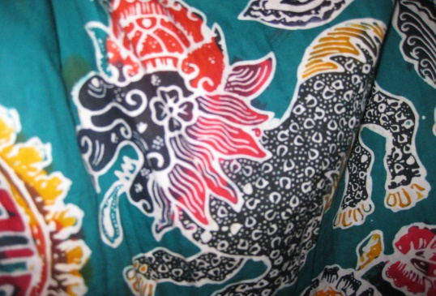
This Photo by Unknown Author is licensed under CC BY
- What is this technique called and what makes it different to other techniques?

- What happens when you paint over your picture on the fabric?

- Why does this happen?

- What is the artist called who makes this art?

- Tell me about the artists style of artwork:

