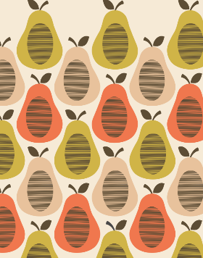
Which famous designer created this pattern?

How has the artist created this pattern?
What 3 things could you use to make this artwork:
1.
2.
3.

How could you make your own version of this piece of art?

What are 3 steps needed to make a stamp in order to create a repeated pattern?

1.
2.
3.

