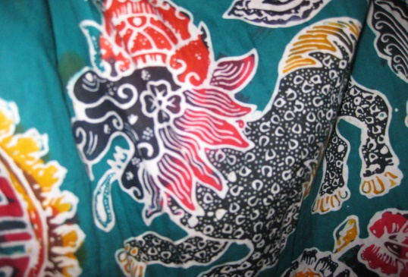
This Photo by Unknown Author is licensed under CC BY
- What is this art called?

- How is it made?

- Tell me the most important thing you need to make this art?

------------------------------------------------------------------------------------

- What is the artist called who makes this art?

