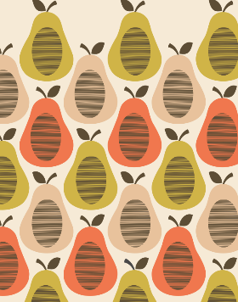
Which famous designer created this pattern?

What technique does this artwork involve?
What are 3 skills needed for this artwork:
1.
2.
3.

Describe the process of making this artwork using your green and gold words:
1.
2.
3.
4.

Can you name 2 different types of stamps you could use for this artwork:
1.
2.

