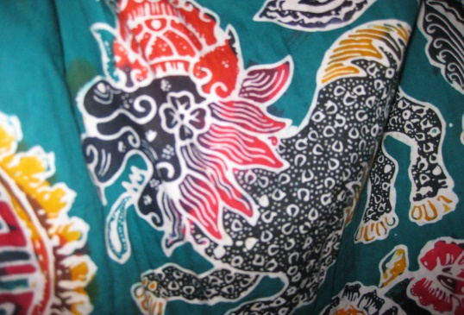
This Photo by Unknown Author is licensed under CC BY
- What is this technique called?

- What could you create using this technique?

- What are 4 resources needed to produce this artwork:
1.
2.
3.
4.

- Tell me why the use of wax and paint together are important for this technique:

- What is the artist called who makes this art?

- Describe the artwork created by this artist:

