Maths Guidance

Pendeen School Maths Principles

Intent
Mathematics is a tool for everyday life and children use maths as a way of viewing and making sense of the world. At Pendeen School, we believe everyone can achieve in maths. We aim to develop a positive ‘can do’ attitude towards maths and an excitement towards it. We nurture a positive attitude where mistakes are seen as an opportunity for learning; encouraging them in the belief that by being resilient they can achieve anything they aspire to. We wish to enable our children to achieve mastery in mathematics by providing learning opportunities to:

• become fluent in the fundamentals of mathematics developing declarative knowledge through varied and frequent practice, so that pupils develop understanding and the ability to recall and apply knowledge rapidly and accurately. Children will be able to show their understanding through the sentence stem, ‘ I know that…’

• reason mathematically developing procedural knowledge through having a specific purpose of each strategy to use, which includes breaking down problems into a series of simpler steps and utilising determination in seeking a solution, developing a justification or proof (‘show me, prove it, convince me’) using mathematical language such as ‘I know how…’

• Use a combination of declarative and procedural knowledge to transform in to strategies to solve problems by applying their mathematical reasoning to a variety of different contexts, ‘I know when…’

Implementation

At Pendeen we utilise White Rose as our underpinning strategy to teach maths to ensure that ‘useful facts, and efficient and accurate methods are paired within a topic sequence’ – this is reflected in the Long Term Planning found on the following pages where Pendeen School have adapted White Rose to suit the needs of ALL Pendeen children. It is important to note that this LTP is not set in stone and shall change with the needs of the children.

Maths in Pendeen’s EYFS strives to provide the foundations that children need to achieve in maths. To ensure coverage of the EYFS curriculum, a separate document (Pendeen School Long Term Maths Plan – EYFS) has been created to represent what maths looks like in EYFS at Pendeen School which includes a week by week breakdown of the focus of learning linked to the White Rose EYFS Scheme of Learning with examples of how planning takes in to consideration the focus for the week. It may be adapted throughout the year to reflect AFL. Children’s learning will be presented in the Kynsa class Learning Journey. There will be clear evidence of when work has been supported and challenges to extend more able pupils. They will record on large, squared paper (this being actively encouraged) when necessary and will show the fundamental skills being taught. Each child will have their own maths books for this and can access at given opportunities across the course of the day.

Across KS1 and KS2, White Rose is used to teach children small connected steps that gradually build upon their understanding effectively supporting them to become proficient mathematicians. Long Term Planning ensures coverage of the National Curriculum and is based on White Rose - adapted to suit the needs of Pendeen’s children. Teacher’s may need to adapt the Long Term Plan as the year progresses as they may need to spend longer on certain areas than others. Lessons will be x5 per week for 60 minutes and will use a variety of different teaching styles to suit all learners, ensuring manipulatives are readily available to support and extend all children. White Rose Teaching slides will be used at the basis for the lesson and adapted to suit the needs of the children. White Rose workbooks will be used to reflect children’s learning and will show their mathematical journey. Questions may be adapted in order to provide variation to ensure children develop a deeper understanding of the concept they are learning. Questions will reflect elements of declarative, procedural and conditional knowledge across the block of learning. Additional questions will be provided to extend children’s learning should it be required which will be signposted to support the child in accessing their journey of their maths learning through the year. Children will be taught in their class groups where it will be the teacher’s digression in how the lesson shall be delivered as long as the essence of the ‘S’ plan below is followed. The driver for this shall be supporting the development of confidence, understanding and ultimately ensuring that ALL children succeed within maths. This explained in the Lesson Structure section.

Standards and Expectations:
It is expected that children take pride within their maths work reflecting high standards of presentation. This also supports children in developing the learning behaviours for maths from the very beginning.

Each child has a blue maths jotter with squared paper relevant to their age group. This is to be used to support the journey of maths for the year. In their book shall be evidence of extensions which challenge and extend the learning focus, as well as completed workbooks and block assessments and photos of working walls which can be refer back to. Each time a new block of learning is begun, this shall be signposted. Any work shown in maths books linked to workbooks will have EXT with the written LF as a clear signpost.
It will be clear in both workbooks and maths books, where support has been given by an ‘S’ being circled by the questions supported. Questions without an ‘S’ are assumed to be completed independently.
At the end of the Block of Learning, White Rose End of Block assessments are carried out and Target Tracker is updated accordingly. Workbooks to be stapled in to maths books with the Block assessment stuck in afterwards. This ensures all work is kept in one place.

Each step of learning will have a title relevant to the learning focus (lf) in the White Rose workbook along with the short date (this could be across a few days). At the end of the step of learning:

If a child has achieved the lf, it will have a double tick;
an awareness, but not secure as single tick;
and an I (intervention) only if not achieved.
Marking will be carried out throughout the lesson alongside the children where possible to ensure misconceptions and mistakes are being addressed swiftly. A tick for a correct response and a dot to reflect a ‘Spot the Mistake’ – children are then actively encouraged in the lesson to ‘Spot their mistake’ and readdress their response by writing it in an area where appropriate. It will then be ticked. An approach of live marking can be taken where children can access the answers and mark their own work in purple pen. This will support them in ‘spotting their own mistakes’ and provide them with opportunities to correct before the end of the lesson ensuring they are ready for the next step in their learning.
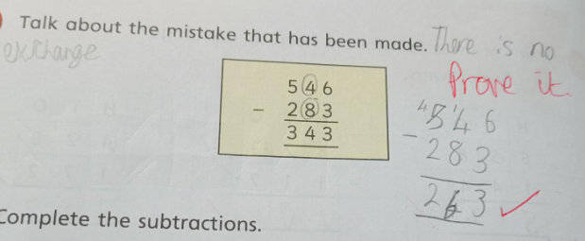

To further children’s learning as required,
responses such as ‘prove it, show me, convince me’
will be written next to the answer to
encourage children to utilise their reasoning skills.

Where numbers have been reversed or written incorrectly, this will be highlighted within marking (a line underneath) and children will rewrite the number several times to practice.

Our aim within mathematics is for all children to become mathematically fluent, using declarative and procedural knowledge to be able to quickly recall number facts and show an understanding of number. A progressive document called ‘Pendeen declarative knowledge plan’ has been created to support children to build solid foundations in number fluency in order for them to have had opportunity to develop ‘I know that…’ which will then be reflective within their learning focus where they have made connections for their procedural knowledge ‘I know how…’

Each child will also have a jotter with squared paper relevant to their age group. This is to be used to support the development of children’s declarative knowledge and provide a record of progress.
The short date is to be used each time the jotter is used.
Each number will be written in one square, including 2 digit numbers (one square each).
Any activities requiring a correct answer is to be marked by the children themselves in purple pen. This is so that children can ‘spot their mistake’.
Each focus shall be titled to show a clear signpost from the declarative knowledge plan.
Teachers shall keep a record of any scores within their planning book to monitor progress and provide interventions when necessary.

Impact
The impact will be measured by how children engage with mathematics; and the development of the love and excitement for maths. This will be shown through the mathematical talk happening throughout Pendeen School and reflected in the standards of maths books. Pendeen School students will be skilled reasoners, drawing upon mathematical language and will apply their problem-solving skills to different contexts within other subjects. This will be monitored with termly pupil conferences.
Maths monitoring through learning walks and book looks by Maths Lead
Maths monitoring and at least one Maths Deep Dive to be carried out alongside our SHIP Partners.
By the end of Key Stage Two, 65% shall meet NARE
Positive Progress shall be demonstrated at the end of Key Stage 2 in Mathematics.

Pictures for curriculum display

Place value  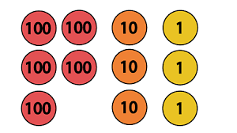 | Addition and subtraction  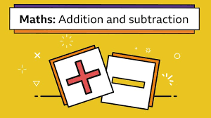 | Number  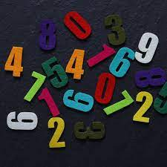
Multiplication and division | FDP  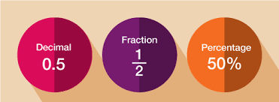 | Measurement  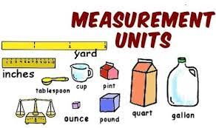
Statistics | Geometry  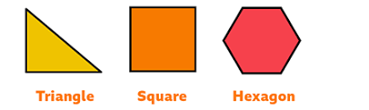

 |  | Reception
Autumn | 1 | Getting to know you
 | 2
 | 3
 | 4 | Just Like Me!
 | 5
 | 6
 | 7 | It’s Me! 1 2 3!
 | 8
 | 9
 | 10 | Light and Dark
 | 11
 | 12
Spring | 1 | Alive in 5
 | 2
 | 3
 | 4 | Growing 6, 7, 8
 | 5
 | 6
 | 7 | Building 9 and 10
 | 8
 | 9
 | 10 | Consolidation
 | 11
 | 12
Summer | 1 | To 20 and Beyond
 | 2
 | 3
 | 4 | First, Then, Now
 | 5
 | 6
 | 7 | Find My Pattern
 | 8
 | 9
 | 10 | On The Move!
 | 11
 | 12
Yearly Long Term Planning Overview linked to White Rose

This is a working document where teachers will update as appropriate
as they know their children’s needs and will adapt blocks of learning as needed, additionally some weeks may take more time or less time relating
to children’s abilities.
*Please note weeks may not match with the amount of weeks in a term. Weeks will be carried over in to the
next term should it be required.

 |  | Y1 | Y2 | Y3 | Y4 | Y5 | Y6
Autumn | 1 | Number: Place Value within 10 | Number: Place Value | Number: Place Value | Number: Place Value | Number: Place Value | Number: Place Value
 | 2
 | 3 |  |  |  |  |  | Number: Four Operations
 | 4 |  |  | Number: Addition & Subtraction |  | Number: Addition & Subtraction
 | 5 |  |  |  | Number: Addition &  Subtraction
 | 6 | Number: Addition & Subtraction within 10 | Number: Addition & Subtraction |  |  | Number: Multiplication & Division
 | 7
 | 8 |  |  |  | Measurement: Area |  | Number: Fractions
 | 9 |  |  | Number: Multiplication & Division | Number: Multiplication & Division | Number: Fractions A
 | 10
 | 11 | Number: Place Value within 20 | Number: Multiplication and division
 | 12
Spring | 1 |  | Number: Multiplication and division | Number: Multiplication & Division | Number: Multiplication & Division | Number: Multiplication & Division | Number: Decimals
 | 2 | Number: Addition & Subtraction within 20
 |  |  | Number: Fractions
 | 3 |  |  |  |  |  | Number: FDP
 | 4 | Number: Place Value within 50 |  | Measure: Length and  perimeter | Measure: Length and Perimeter | Number: Fractions B
 | 5 |  |  |  |  |  | Geometry: Shape
 | 6 | Number: Multiplication and Division |  |  | Number: Fractions | Number: Decimal and percentages
 | 7 |  |  | Number: Fractions
 |  |  |  |  |  |  | Geometry: Position and direction w Y5 recap
 | 8 |  | Statistics
 | 9 | Number: Fractions |  |  |  | Measure:  Perimeter and area | Measure: Area, perimeter and volume w Y5 recap
 | 10 |  | Measurement: Time | Measurement: Mass and capacity w/ Y2 recap | Number: Decimals
 | 11 |  | Measure: Money
 |  |  |  |  |  | Statistics w/ recap Y4 | Statistics
 | 12 | Measure: Money |  |  |  |  | Teacher assessed SATs based intervention
Summer | 1 | Geometry: Shape | Geometry: shape | Number: Fractions | Number: Decimals | Geometry: Shape | Teacher assessed SATs based intervention w/ ratio, algebra,
 | 2 | Geometry: Position and Direction
 | 3 | Number: Place Value within 100 | Teacher assessed SATS based intervention w/length and height, capacity, temperature, mass, position and direction.
 | 4 |  |  | Measurement: Money w/ Y2 recap | Measurement: Money | Geometry: Position & Direction
 | 5 | Measure: Time
 | 6 |  | SATS | Measurement: Time w Y2 recap | Measurement: Time | Number: Decimals | Consolidation and Problem Solving themed Projects
 | 7 | Measure: Length and height | Measure: Length and height  Measure: Capacity and temperature
 | 8 | Measure: Weight and volume |  |  | Geometry: Shape w Y3 recap
 | 9 |  |  | Geometry:
 |  |  |  | Shape | Geometry: Position and Direction | Number: Negative numbers
 | 10 | Consolidation/ problem solving | Consolidation/ problem solving |  |  | Measurement: Converting Units
 | 11 |  |  | Statistics | Statistics w/ Y3 recap
 | 12 |  |  |  |  | Measure: Volume

Resources for planning

* White Rose Schemes of Learning https://whiterosemaths.com/resources/primary-resources/
* Premium Resources from White Rose https://resources.whiterosemaths.com/resources/ - All staff have been provided with their own usernames and passwords to access. They should email Rebecca Sedgeman should they have any issues logging in. Teachers adapt the teaching powerpoints to suit the needs of the children in the POP groups they oversee.
* EYFS Planning – See Pendeen School Long Term Plan - EYFS TBC
*Timestable Rockstars (TTRS) for learning times tables – Teacher’s set tables relevant to the children in their POP groups and monitor as appropriate through statistics on TTRS and through 99 Club. Tournaments will be set up between classes to encourage healthy competition and provide an extra incentive.
* Numbots for learning number bonds – Teacher’s set relevant stories for children to complete across EYFS and KS1.
*Vocabulary document provided to all teaching staff to support vocabulary during lessons and on working wall – Document saved in Staff Share → Maths → Calculation Policy and Planning Guidance
*Calculation Policy on staff share
*Diving for Mastery Materials on staff share
*NCETM Ready to Progress materials on staff share
*Oxford Owls on Staff share

Lesson Structure

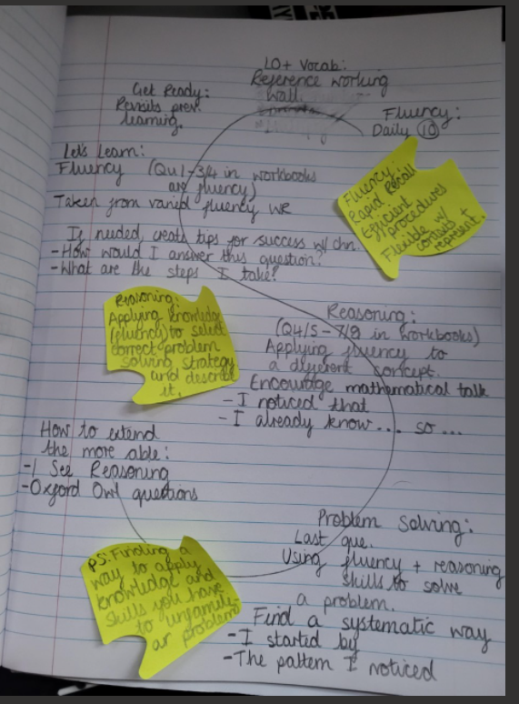
Main Input:
Some learning focuses may take more than one lesson to ensure we are meeting the needs of all children. For the purpose of lesson structure, this is what is expected for a learning focus (not a specific 60 minute lesson).

Introduce learning focus with steps to success
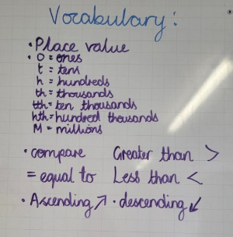
– refer to vocabulary on working wall ‘my turn, your turn.’ Ask if anyone needs reminding of any vocabulary. ‘Can anyone help to explain this?’ Other children to help out.

Re-address previous learning – GET READY
- This could be through a conjecture. For example, Bob says, ‘200 > 300’. Prove it. Chn are then encouraged to use their reasoning to provide evidence for or against Bob.
- This could be using the ready-made slide on the White Rose Teaching Slides

Using the teaching slides, teach children the LF – LET’s LEARN
- Teachers will adapt the White Rose Teaching Slide to suit the needs of their children.
- When working through the slides, they will need to assess children’s understanding through targeted questioning.
- Ensure to provide opportunities for children to show their understanding by asking them to demonstrate it however you see fit – evidence for this shall be reflected within their independent work within workbooks.
- Depending on the needs of the children, you may choose to work through most of the slides before they work independently in their work books.
- Make use of maths working wall to provide a working model
- Use ‘Tips for success’ This encourages children’s independence when working in their workbooks. They can refer to it as much as they would like.
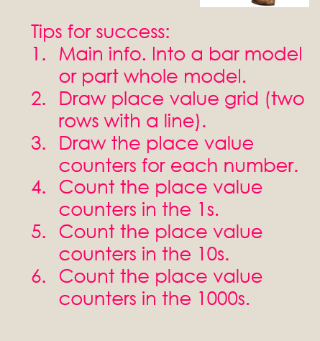
Tips for success should be left on the working wall and children encouraged to utilise throughout the lesson to encourage independence and as well as support themselves in answering questions. This should help them internalise the steps necessary in answering problems later on.

They could already be written in to the lesson powerpoint. Or written on the board as you go so that children can see it’s a working model and make contributions providing ownership.

Presentation Convention
Each learning area has the required maths manipulatives needed to support children to succeed within maths and ALL children know where these are.
Each class has a Maths working wall which will include:
- Vocabulary relevant to the unit of learning taken from the White Rose planning and Pendeen School’s Calculation Policy
- Working models, relevant to the current unit of learning, being built upon as learning progresses
- A signpost for resources to be used
- Sentence/ question stems that can be utilised within a lesson by adults and children alike
- The statement: ‘Use the known to find the unknown’.

REMEMBER to take pictures of working walls before erasing and placing them into children’s maths books to refer back to.

Workbooks and maths books
Each step of learning will have a title relevant to the learning focus (lf) in the White Rose workbook along with the short date (this could be across a few days).
Each child has a blue maths book with squared paper relevant to their age group. This is to be used to support the journey of maths for the year. In their book shall be evidence of extensions which challenge and extend the learning focus, as well as completed workbooks and block assessments and photos of working walls which can be refer back to. Each time a new block of learning is begun, this shall be signposted.

Any work shown in maths books linked to workbooks will have EXT with the written LF as a clear signpost.
It will be clear in both workbooks and maths books, where support has been given by an ‘S’ being circled by the questions supported. Questions without an ‘S’ are assumed to be completed independently. V
At the end of the Block of Learning, White Rose End of Block assessments are carried out and Target Tracker is updated accordingly. Workbooks to be stapled in to maths books with the Block assessment stuck in afterwards. This ensures all work is kept in one place.

Each step of learning will have a title relevant to the learning focus (lf) in the White Rose workbook along with the short date (this could be across a few days). At the end of the step of learning:
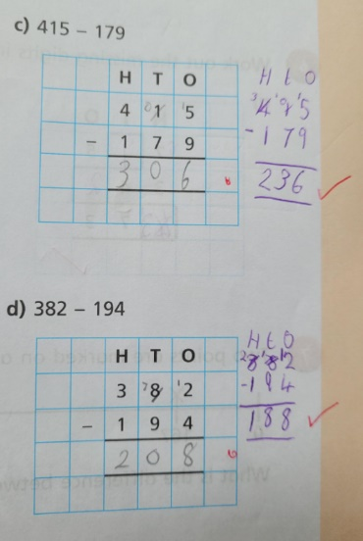
If a child has achieved the lf, it will have a double tick;
an awareness, but not secure as single tick;
and an I (intervention) only if not achieved.
Marking will be carried out throughout the lesson alongside the children where possible to ensure misconceptions and mistakes are being addressed swiftly. A tick for a correct response and a dot to reflect a ‘Spot the Mistake’ – children are then actively encouraged in the lesson to ‘Spot their mistake’ and readdress their response by writing it in an area where appropriate. It will then be ticked. An approach of live marking can be taken where children can access the answers and mark their own work in purple pen. This will support them in ‘spotting their own mistakes’ and provide them with opportunities to correct before the end of the lesson ensuring they are ready for the next step in their learning.

To further children’s learning as required,
responses such as ‘prove it, show me, convince me’
will be written next to the answer to
encourage children to utilise their reasoning skills.

Where numbers have been reversed or written incorrectly, this will be highlighted within marking (a line underneath) and children will rewrite the number several times to practice.

Jotters
Each child will also have a jotter with squared paper relevant to their age group. This is to be used to support the development of children’s declarative knowledge and provide a record of progress.
The short date is to be used each time the jotter is used.
Each number will be written in one square, including 2 digit numbers (one square each).
Any activities requiring a correct answer is to be marked by the children themselves in purple pen. This is so that children can ‘spot their mistake’.
Each focus shall be titled to show a clear signpost from the declarative knowledge plan.
Teachers shall keep a record of any scores within their planning book to monitor progress and provide interventions when necessary.

