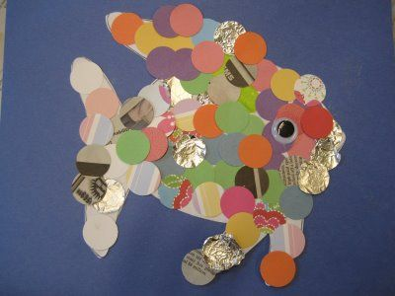
What is this type of artwork called?

What is the name of an artist who makes these types of art?
What 3 things could you use to make this artwork:
1.
2.
3.

What does it mean to ‘layer’ the materials?

