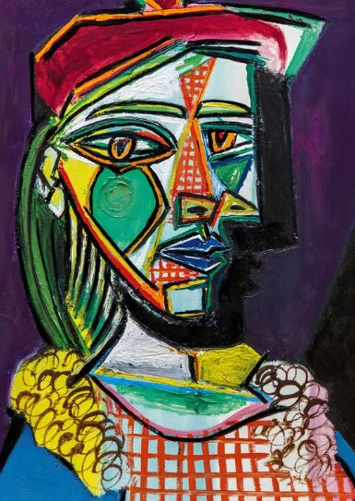
Which artist painted this picture?

Describe the differences between a standard self portrait and a Picasso self portrait?

There are 3 colours we mix to make new colours. These are called primary colours. What are they?
1.
2.
3.

Which 2 colours are mixed to make:

Purple _______ + __________

Orange _______ + __________

Green ________ + __________

How can you change the warmth of a picture?

Which type of paint is best suited to create vibrant bright colours?

