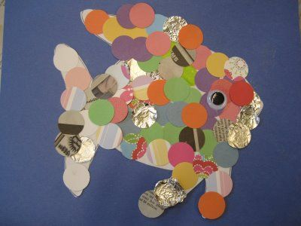
What is this type of artwork called?

Name an artist who creates this type of artwork?
How would you create a ‘mosaic’?

What are 3 important steps to remember when creating this technique:
1.
2.
3.

How could you change the texture of the picture to create the appearance of ‘fur’?

