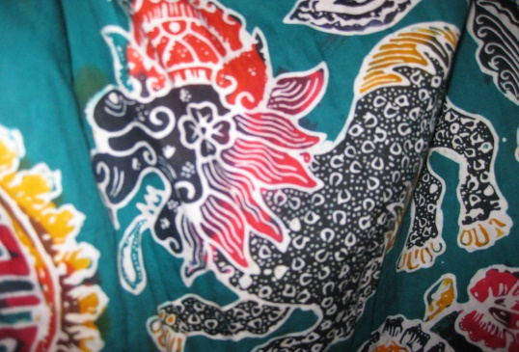
This Photo by Unknown Author is licensed under CC BY
- What is this technique called?

- How can patterns be created using this technique?

- What skills do you need for this technique:
1.
2.
3.
4.

- List the resources (using technical names where appropriate) needed to produce this artwork:
1.
2.
3.
4.
5.
6.
7.

- Explain, in order, 5 steps to make this artwork (the first one has been done for you):

- Heat up the wax in the wax burner, ensuring it is hot enough to pour.

- Describe how you could change the texture of the artwork:

