**Free**

Take 3 **Support for parents and carers   
of teenagers**

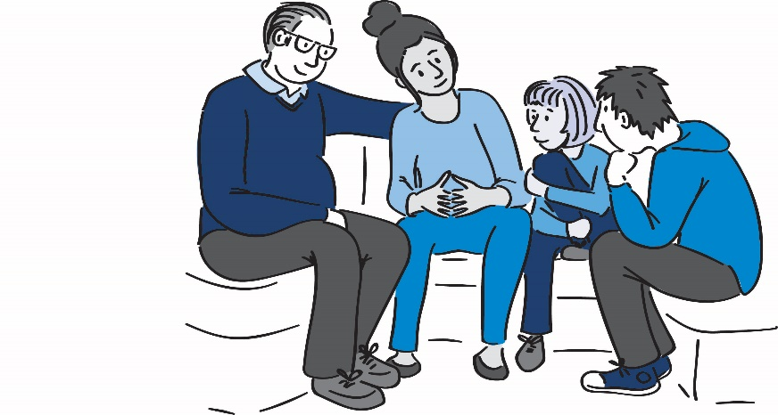

For mums, dads, grandparents and carers of teenagers

**Sessions include:**

* How to encourage, motivate and   
  support young people
* Helping parents look after themselves
* Negotiate boundaries that work

An informal and friendly programme,   
run over 10 sessions

Whether you have current worries about your teenager or would just like to understand your child better, **this programme will have something for you.**

Further information

Mondays 20th September – 29th November (excluding half term)

18:00-20:00

Redruth Family Hub, Drump Road, Redruth, TR15 1NA

To request a place, visit: [www.cornwall.gov.uk/earlyhelphub](http://www.cornwall.gov.uk/earlyhelphub)

Click on ’Request for Help’, then on the request for help form.   
Complete, save and email to [earlyhelphub@cornwall.gov.uk](mailto:earlyhelphub@cornwall.gov.uk)