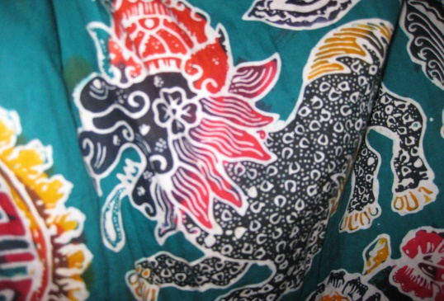
This Photo by Unknown Author is licensed under CC BY
- What is this technique called?

- Tell me 3 resources you used for this artwork:
1.
2.
3.

- What are 2 steps to making this artwork?

1.

2.

- What is the artist called who makes this art?

