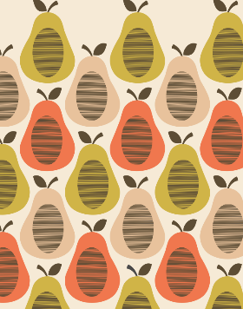
What is the full name of the famous designer who created this pattern?

What technique does this artwork involve?
What are 4 skills needed for this artwork:
1.
2.
3.
4.

Describe the process of making this artwork using your green and gold words:
1.
2.
3.
4.

Explain how to use ink rollers in order to print:
1.
2.
3.

