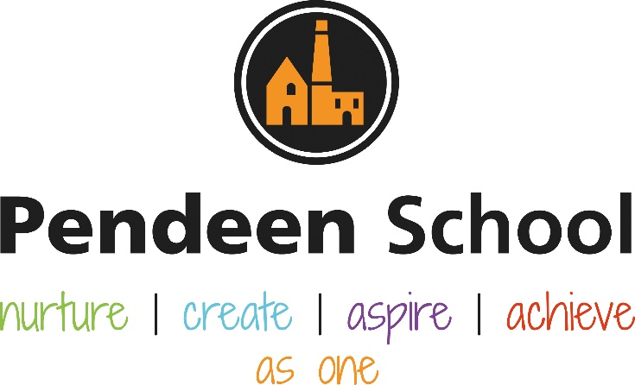

Art Guidance

Pendeen School Art and Design Principles

Intent
The national curriculum for art and design aims to ensure that all pupils:
♣ produce creative work, exploring their ideas and recording their experiences
♣ become proficient in drawing, painting, sculpture and other art, craft and design techniques
♣ evaluate and analyse creative works using the language of art, craft and design
♣ know about great artists, craft makers and designers, and understand the historical and cultural development of their art forms.

Pupils in Early Years should be able to (by the end of the academic year):
- Explore, use and refine a variety of artistic effects to express their ideas and feelings.
- Return to and build on their previous learning, refining ideas and developing their ability to represent them.
- Create collaboratively, sharing ideas, resources and skills.

Key stage 1 Pupils should be taught:
- to use a range of materials creatively to design and make products
- to use drawing, painting and sculpture to develop and share their ideas, experiences and imagination
- to develop a wide range of art and design techniques in using colour, pattern, texture, line, shape, form and space
- about the work of a range of artists, craft makers and designers, describing the differences and similarities between different practices and disciplines, and making links to their own work.

Key stage 2 Pupils should be taught to develop their techniques, including their control and their use of materials, with creativity, experimentation and an increasing awareness of different kinds of art, craft and design.
Pupils should be taught:
- to create sketch books to record their observations and use them to review and revisit ideas
- to improve their mastery of art and design techniques, including drawing, painting and sculpture with a range of materials [for example, pencil, charcoal, paint, clay]
- about great artists, architects and designers in history.

At Pendeen School we encourage creativity and the development of a unique style of artwork produced by each individual child. We foster a love of creativity and ensure children are provided with the opportunities, skills and resources they need in order to become successful young artists.
We teach art across the school using the National Curriculum and ensure there is a clear progression of skills across the school.
Teachers communicate and work together collaboratively to ensure skills progression is understood and taught effectively in order to provide the best knowledge, skills and opportunities for the children at Pendeen School. Planning is carefully structured and provided by our school Art lead and covers Reception up to Year 6 with a whole school theme or topic underpinned by the half termly skill we are learning. Each skill set is linked to the relevant local and national artist we are exploring including both modern and historical artists.
“Work with creative practitioners raised pupils’ aspirations and achievement in primary and secondary schools” (Making A Mark, OFSTED, 2011). At Pendeen School we ensure children observe local artists at work and encourage local artists to work with the children, offering an insight into this subject as a vocation. By working with local artists we ensure children have opportunities for ‘real life’ experiences and aim to inspire the children to feel and be creative.
We value the work of local artists and maintain good links with the local community as well as learning about historical artists and artists from a national or even worldwide fame (such as Andy Warhol and Picasso). We provide rich learning experiences to see and create artwork in various different styles by visiting galleries and taking part in art on larger scales (eg natural art in outdoor settings such as the local beach and Carn in Pendeen). Our aim is that children enjoy being creative and take pride in producing art of many forms.

At Pendeen School we feel that art as a subject engages the children in a process that helps in the development of self-esteem, self-discipline, cooperation, and self-motivation. All members of staff encourage self-belief and instill confidence in every child from the day they start their learning journey. It is important for children to understand there is no right or wrong direction in art and that every outcome should be celebrated.

Implementation
The art curriculum is planned from EYFS up to Year 6, ensuring that every child can access each lesson with age, ability and core curriculum values at the heart of the delivery.
The Art lead communicates with every teacher to ensure resources are appropriate and accessible for all learners. At Pendeen School we remove any potential barriers to learning by providing tailored planning, appropriate resources and a warm learning environment with the culture that we can all have a go.
Teachers are offered CPD in the subject to enhance artistic skill set and all members of staff feel confident to join in with and teach the activities.
Where possible, the school takes part in whole school art events such as creating memorial artwork to commemorate the Levant tin mine disaster. This provides an opportunity to show the clear skills progression from reception right through to year 6.
Teachers work closely with local artists to create community links and teach the children about various different artistic styles. Children learn about local artists, national and worldwide famous artists and both modern and historic art forms.
Children learn a range of artistic skills starting from learning and understanding the foundations (e.g. colour recognition and mixing) right the way through to areas of learning that rely on prior knowledge and develop existing skill sets (for example after children have learnt the colours and how to mix new colours they can begin to understand how to apply different layers, change the texture of their painting and eventually add detail for a purpose).
Children take part in whole school art events which are planned and delivered to ensure all children have the opportunity to feel a sense of creative achievement. All artwork is celebrated within the school.

Impact
Children at Pendeen School talk with enjoyment about the subject.
Children at Pendeen School take pride in the development of their artwork and understand that they are learning the artistic skills in order to develop their own creative style.
Children can select the appropriate tools to enhance their artwork and understand the reasons behind their choices.
Children understand how to use a range of techniques and develop their ability to implement the skills, which is reflected in their final artwork.
Art lead will monitor the teaching and learning of art and invite children to discuss and share their thoughts on the subject.
Every child at Pendeen School has an art folder which displays their artwork from Reception up to Year 6.
Artwork is displayed on the walls in the corridors of the school where every child feels a sense of achievement and takes pride in their learning.
The Art leader (Becky Curnow) monitors the progression of each skill throughout each half term through lesson observations, discussions with children and in viewing their artwork.

Rolling Programme – Information for staff
Term | Skill | Year / Outcome / Artist | Examples of relevant artwork
Autumn 1 | Colour | A 3D Self Portraits  Pablo Picasso - Cubism | 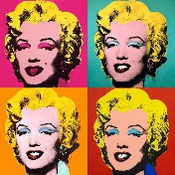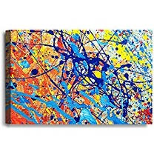
B Self Portraits
Andy Warhol – Pop art
Autumn 2 | Printing | A Christmas Wrapping Paper  Jaqueline Wild, Orla Kiely | 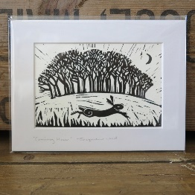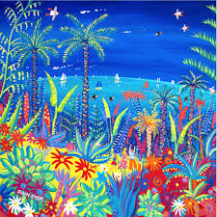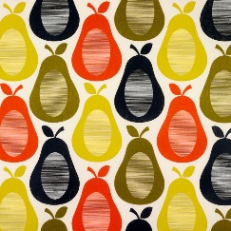
B Landscape – Winter / Christmas
John Dyer
Spring 1 | Texture | A Implied / Visual Texture  Claude Monet – build up paint | 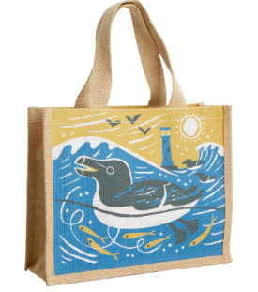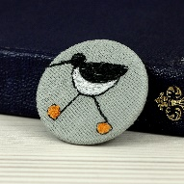
B Tie Dye; Design and make a product for Seasalt
EY: tshirts KS1: bags LKS2: eye mask UKS2: wall hanging
Spring 2 | Form | A Collaborative Mosaic  Antoni Gaudi (international)  Karen Harry (local) Cornish Engine House – include sea glass | 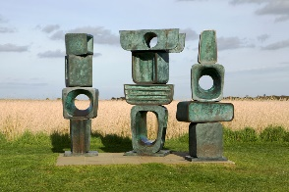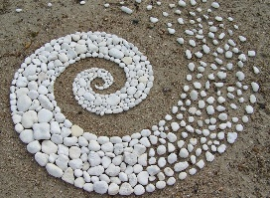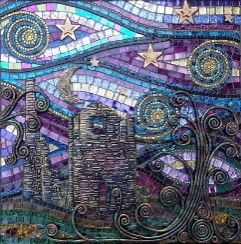
B Clay Home and Garden Ornaments
Barbara Hepworth – clay
Andy Goldsworthy – beach sculpture
Summer 1 | Pattern | A Tessellation  MC Escher - Animals in pattern | 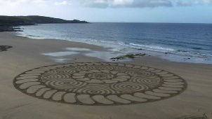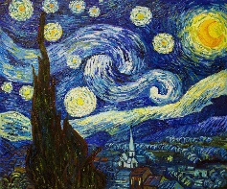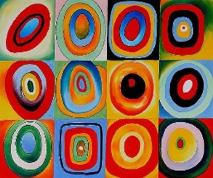
B Seasonal Painting
Van Gogh – Starry Night
Chris Haworth - sand art by the beach
Summer 2 | Drawing | A Cornish Wildlife  Local birds, feathers | 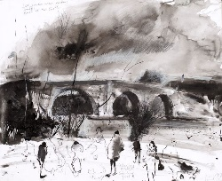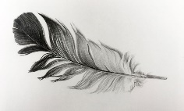
B Nature Sketching
Kurt Jackson

Rolling Programme – Information for parents
Term | Skill
Autumn 1 | Colour | It is important that our Art and Design Curriculum starts with the key foundations of what every artist needs to have a good understanding of before we can develop more technical skills. All children learn what the primary colours are and how to mix alternate colours from these in the Autumn term. Now we know more about colour mixing, we can use them to create our own masterpieces.
Autumn 2 | Printing | We want all children at Pendeen School to learn practical art and design skills that can be transferred into real experiences including hobbies and occupations. Children will learn to print in various ways linked to the seasonal change of Winter and religious festival of Christmas. While learning this skill children will create a product that can be shared among the community to encourage kindness towards others.
Spring 1 | Texture | Texture in art concerns the surface quality of a piece of work. In three-dimensional artwork, the term refers to how the piece feels when it’s touched. In paintings and other two-dimensional artwork, texture invokes the visual ‘feeling’ the piece gives off. At Pendeen School we give all children the opportunity to have a go at both techniques and make an item with a purpose that each child can keep (tshirts, bags, cosmetic products, wall hangings)
Spring 2 | Form | Children will use clay to create a product with a purpose for themselves as well as a collaborative piece as a whole school linked to local Cornish history, more specifically the tin mining era. Children will learn about both local and international artists and compare the work of the two. While learning this skill children will have the opportunity to visit The Tate Gallery in St Ives to look at sculptures as inspiration as well as make transient art during local beach and woodland visits.
Summer 1 | Pattern | Children at Pendeen School learn to develop this skill towards the end of the year as we learn to build on more enhanced skills involving mathematical knowledge and finer detail. Children will recreate large scale artwork in the style of artists such as Van Gogh and also learn how to create ‘tessellations’ using inspiration from digital artist MC Escher linked to the interests of the children.
Summer 2 | Drawing | By the end of the year all children at Pendeen School will have the fine motor skills and strength required to create detailed drawings and learn how to sketch using knowledge of artistic skill already learnt earlier in the year; adding finer details, shading, tone and texture. We are very fortunate to have amazing local artists who will lead workshops at Pendeen School which in turn show the children that art and design can be used in many ways to improve wellbeing as a hobby but can also lead to a professional career.

Rolling Programme – Pictures for curriculum display
 | Year B Aut 1 | Year B Aut 2 | Year B Spring 1 | Year B Spring 2 | Year B Summer 1 | Year B Summer 2 | Year A Aut 1 | Year A Aut 2 | Year A Spring 1 | Year A Spring 2 | Year A Summer 1 | Year A Summer 2
EYFS | 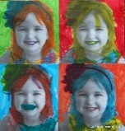 | 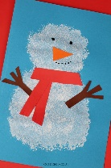 |  | 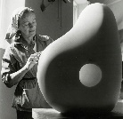 | 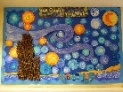 | 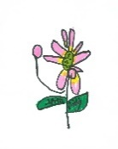 | 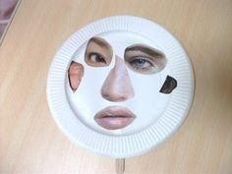 | 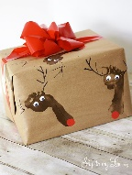 |  | 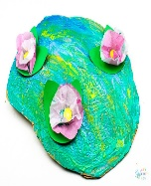  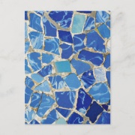 | 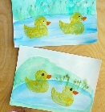 | 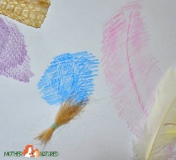
KS1 | 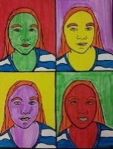 | 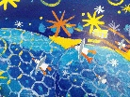 | 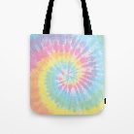 | 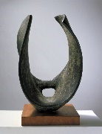 | 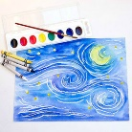 | 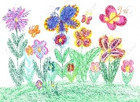 | 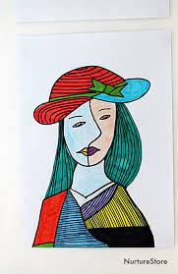 | 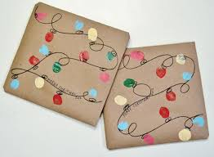 | 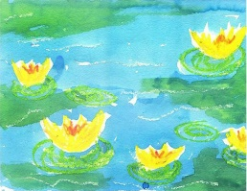 | 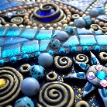 | 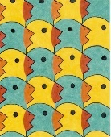 | 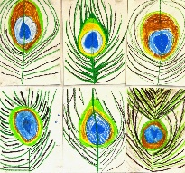
Lower KS2 | 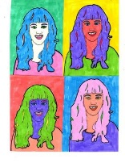 | 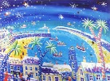 | 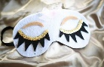 | 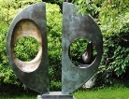 | 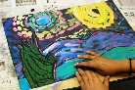 | 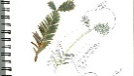 |  | 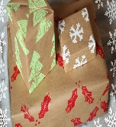 | 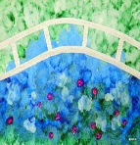 | 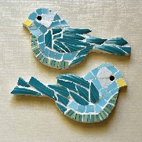 | 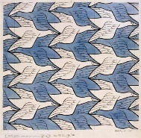 | 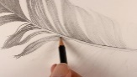
Upper KS2 | 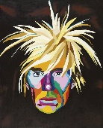 | 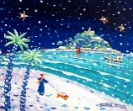 | 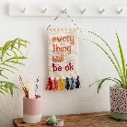 | 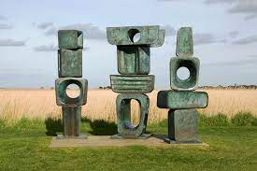 | 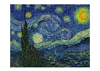 | 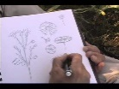 | 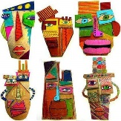 |  | 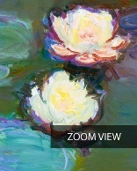 | 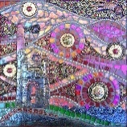 | 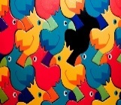 | 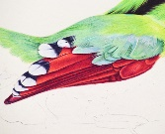

Resources for planning

*We follow the Art programme designed by Becky Curnow (class teacher) to insure coverage and content is appropriate for age and stage across mixed age classes.
*Planning starts with the needs of our youngest learners and broadens to show progress across the school. An example of this is ensuring we teach ‘colour’ first as without an understanding of the colour names and how to make colours by mixing, our children cannot be expected to develop skills of painting and texture.
*Each half termly plan incorporates both a local and national artist for children to learn about and have a go at developing the skill of the specific artist, for example we learn about Cornish artist Karen Harry when we learn to create Mosaics for progression of ‘form’ and we also link, compare and learn about Anthoni Gaudi, worldwide famous artist.
*All planning for Year A is completed and all teachers have a copy to follow with age appropriate planning and resources purchased by our art lead at least 1 half term in advance.
*Planning for Year B (year 2021/2022) is in progress and is given to teachers 1 half term in advance e.g. teachers receive planning and resources for Spring 1 in Autumn 2.
*Visitors and local artists are planned for and welcomed into the school each half term depending on the skills required to teach and the lessons being delivered.

Lesson Structure

We dedicate one afternoon per week to art lessons however some terms teachers may choose to block their art lessons.
We start each block of learning by looking at a new artist, comparing their work to a previously learnt about artist of a similar skillset and forming opinions on their style of artwork. An example of this is learning about Andy Warhol’s ‘pop art’ style of self portrait before learning about Picasso’s abstract portraits.
Art lessons are practical, immersive and offer children the opportunity to be creative, unique and find their own style of art.
Every child’s artwork is displayed on the walls in the corridor outside of each class in our whole school art gallery. The artwork displayed in the corridor offers a chance to visually see the progression starting from viewing art in EYFS through to Year 6.
We use Target Tracker to assess.

Presentation Convention
Every child has an art folder to display their artwork in from EYFS up to Year 6.
Children can look back on their artwork to compare artists, styles of art and celebrate their progression across the year groups.
Every piece of artwork is designed and made by the child themselves and celebrated as unique.
Classrooms display artwork from the artist we are currently learning about eg Picasso.

