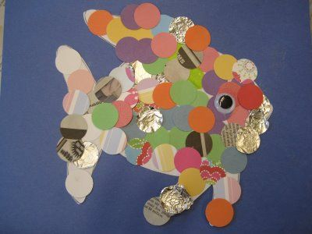
What is this type of artwork called?

Name an artist who creates this type of artwork:
How would you create a ‘mosaic’?

Explain 3 steps needed to create a collage:
1.
2.
3.

Why would an artist add ‘layers’ to their collage?

