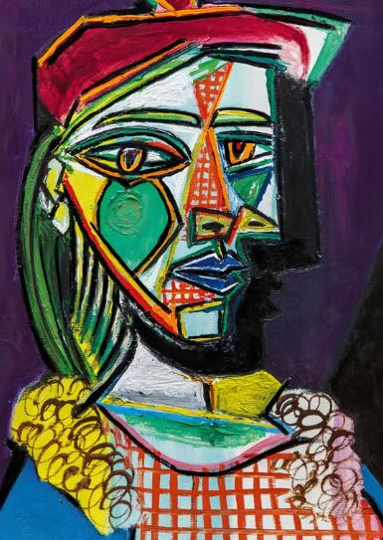
Which artist painted this picture?

What is special about this artists paintings?

There are 3 colours we mix to make new colours. These are called primary colours. What are they?
1.
2.
3.

Tell me about 2 colours you can mix to make a new colour:

__________ + ___________ makes ___________

__________ + ___________ makes ___________

