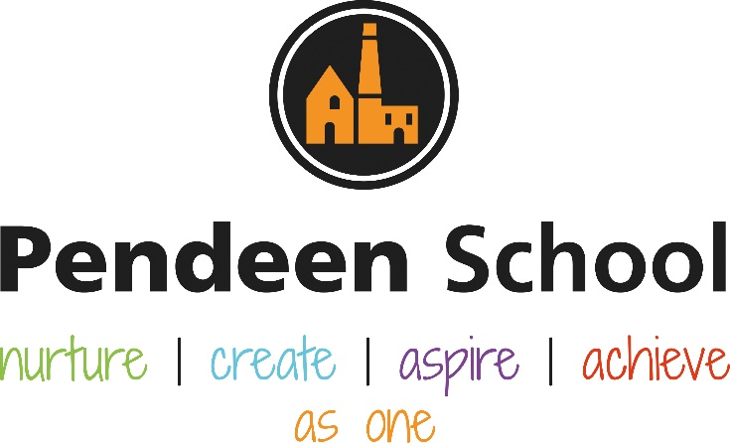

PSHE Guidance
Including updated RSHE curriculum

Pendeen School PSHE Principles

Intent
(see attached document for skills progression of each PSHE area for children at Pendeen School)
The content of PSHE sessions at Pendeen School are taught sensitively and inclusively, with respect to the backgrounds and beliefs of pupils and parents while always with the aim of providing pupils with the knowledge they need of the law.
The topics we cover within PSHE sessions are the key building blocks of healthy, respectful relationships, focusing on family and friendships, in all contexts, including online. This delivers alongside the essential understanding of how to be healthy.
At Pendeen School we ensure that every child has the opportunity to receive high quality PSHE education which includes; mental health and well-being, physical health (including healthy lifestyle choices and first aid) and that every child learns about safe and healthy relationships, including understanding consent and how to be safe online.
To embrace the challenges of creating a happy and successful adult life, pupils need knowledge that will enable them to make informed decisions about their wellbeing, health and relationships and to build their self-efficacy. Pendeen School recognises that an effective PSHE curriculum can improve both the physical and mental health of our pupils. High quality, evidence-based and age-appropriate teaching of these subjects helps prepare our pupils for the opportunities, responsibilities and experiences of adult life.
Pendeen School maintains a close relationship with parents to ensure parents are kept up to date with the content of PSHE lessons.
Implementation
Relationships, social, health and economic (RSHE) education is a planned programme of school-based learning opportunities and experiences within the PSHE curriculum that deal with the real life issues children and young people face as they grow up. It comprises two strands: personal wellbeing and economic well-being.
The personal well-being strand can cover issues such as:
• sex and relationships education;
• drug and alcohol education;
• emotional health and well-being;
• diet and healthy lifestyle; and
• safety education.
The economic well-being strand can cover issues such as:
• enterprise education; and
• financial capability.

Evidence shows that relationships, social, health and economic (RSHE) education can improve the physical and psychosocial well-being of pupils. “Taking a whole school approach to health and well-being is linked to pupils’ readiness to learn.” A recent review of the link between pupil health and wellbeing and attainment advocated promotion of health and well-being as an essential element of a school’s effectiveness strategy (Public Health England, 2014).
A report by the chief medical officer of England stated that promoting physical and mental health in schools can reinforce children’s attainment and achievement that, in turn, can improve their well-being (Brooks, 2012). This research alongside the Early Years curriculum approach that Relationships Social and Economic development is a prime area is a very important part of our delivery of RSHE sessions across the school where we value mental health and wellbeing among the children and parents within our local community as well as the staff working in the school.

At Pendeen School we use the ‘3D PSHE’ planning scheme to deliver lessons from reception right through to year 6. We ensure that every year group has weekly PSHE sessions built into their timetable with the opportunity for talking and sharing thoughts. Lesson plans taken from the ‘3D PSHE’ planning scheme are adapted where appropriate to meet the needs of the children at Pendeen School. Teachers at Pendeen School recognise that emotional needs change over time and as a result, staff ensure that the content of lesson plans reflects this.

At Pendeen School we recognise the ever expanding digital world can be a large part of a child’s life from an early age. We support children in understanding the difference between the reality of life experiences and those that are virtual / online experiences. We help children to understand how to stay safe online, offer guidance on games and websites to access at an age appropriate level and work with parents to make their devices safer at home. We help children make decisions about the content they access online by developing internet safety awareness from Reception up to Year 6. We understand that these lessons and discussions will help children in their wider life and give the children the tools and skills they need to stay safe. We ensure that children feel there are trusted adults within the school to confidentially talk to at any point during their school day whether it is to discuss an issue at school, at home or online.

PSHE lead Becky Curnow will monitor PSHE lessons across the school looking for effective delivery of lessons. Children will be engaged, feel confident to discuss the topic and show clear progression through discussion with the children and by observing prior learning in floorbooks.

School governors will work alongside the PSHE lead to discuss teaching and learning as well as observe PSHE lessons in action.

Regular SHIP visits will take place to work with local heads and RSHE leads in order to effectively monitor and ensure a high quality of teaching and learning is taking place.

Our Designated Safeguarding Lead Chris Wilson and Deputy Safeguarding Lead Becky Curnow will ensure the wellbeing of staff and children is priority and take the relevant and appropriate actions (support for staff, working closely with families particularly in times of need, keeping safeguarding records up to date and informing the MARU of any safeguarding concerns).

Impact
Children are able to talk about how to keep safe and be able to explain how and where to get help.

Every child will be continually assessed for Relationships, Social, Health and Economic development via Target Tracker from YR – Y6 and show progress.

Children receive appropriate and tailored support for their individual needs.

Motional assessment can be carried out for the individual child at any time.

Our SENCO and Ed Psych work closely with children who require additional support for their relationship, social or emotional need/s.

Effectiveness of the curriculum will be evaluated through the responses of discussions with children. Floor books will show progress of individual children within each year group.

Behaviour for learning will be good and barriers to learning caused by potential relationship, social or emotional needs will be assessed and removed by teachers by taking appropriate steps to ensure every child can access learning.

Rolling Programme – Information for staff
Term | Area of Learning | Area of learning from 3D plans
Autumn 1 | Relationships | EYFS – Emotions  KS1 – Core 1 Emotions  LKS2 – Core 2 Relationships Collaboration and Bullying  Year 5/6 - Core 2 Relationships Communication and Collaboration
Autumn 2 | Relationships | EYFS - Communication  KS1 – Core 2 Communication and Bullying  LKS2 – Core 2 Relationships Similarities and Differences and Healthy relationships  Year 5/6 - Core 1 Emotions and safety
Spring 1 | Relationships  Health and Wellbeing  Living in the Wider World | EYFS – Family and Friends  KS1 – Fairness and Family and Friends  LKS2 – Core 1 Living in the Wider World  Year 5/6 - Core 1 Health Core 2 Diversity
Spring 2 | Living in the Wider World  Health and Wellbeing UKS2 | EYFS – Living in the Wider World – rules and responsibilities, local community  KS1 – Living in the Wider World – rules, responsibilities and communities  LKS2 – Core 3 Living in the Wider World, Discrimination and Economic Awareness  Year 5/6 - Core 1 Health and well being, Food, Aspirations
Summer 1 | Living in the Wider World | EYFS – Keeping Safe  KS1 – Living in the Wider World – money and finance  LKS2 – Catch up class focus  Year 5/6 - Core 3 Living in the Wider World, Rules/ Responsibilities
Summer 2 | Health and Wellbeing | EYFS – Health – changing and growing, hygiene, SRE  KS1 – Health – changing and growing, hygiene, SRE  LKS2 -Catch up class focus - SRE  Year 5/6 - SRE + Core 1 Health, Core 2 Healthy Relationships Y6 – Economic Awareness and Enterprise

Rolling Programme – Information for parents
Term | Skill
Autumn 1 | Relationships | Children begin their school journey understanding their likes and dislikes, making choices and decisions, recognise similarities and differences amongst each other and respect other cultures and people in different communities. Over the years children will understand the different types of relationships and learn how friendships support wellbeing. Children learn how to understand and regulate their emotions as well as how to effectively communicate their feelings to others.
Autumn 2
Spring 1 | Living in the Wider World | Children in EYFS learn about and understand different cultures within society. We teach children about the different roles people play in our local community, including the emergency services. We take great pride in having a positive relationship within the community and enjoy experiences from visitors who can share first hand their way of life that sometimes may differ from ours.  Pendeen School provides children with a caring and nurturing environment where children learn to care for all living things including humans and animals. Children learn to take responsibility for their environment and take part in discussions about topics like single use plastics, fairtrade and climate change.  Children begin to understand money and finance, learning how to save and the importance of appreciating things we’ve worked hard for.  We ensure all children learn about the positive and negative impact the internet can have and how to use the internet safely as well as trusted adults to speak to about any concerns online.
Spring 2
Summer 1 | Health and Well Being  Relationships - SRE | Children will understand how to maintain good hygiene including oral hygiene, bathing and self care.  Children will be taught about mental health and well being and how to support themselves and others, including who to speak to should they feel concerned about themselves, a friend or family member.  All children will learn basic first aid including important life skills required living in Cornwall such as sea and beach safety.  At Pendeen School we feel it is important that children receive Sex and Relationship Education when they are nearing the end of their primary school journey and therefore in a more mature place to learn and understand as well as take the information forward into their secondary school journey where relationships may change and evolve.
Summer 2

Rolling Programme – Pictures for curriculum display
 | Year A Aut 1 | Year A Aut 2 | Year A Spring 1 | Year A Spring 2 | Year A Summer 1 | Year A Summer 2 | 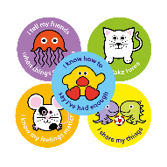  Year B Aut 1 | Year B Aut 2 | Year B Spring 1 | Year B Spring 2 | Year B Summer 1 | Year B Summer 2
EYFS |  |  |  |  | 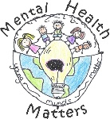 | 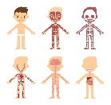
KS1
Lower KS2
Upper KS2

Resources for planning

*Personal Social and Emotional development is at the heart of everything we do at Pendeen School and is embedded within our nurturing school ethos.
*At Pendeen Primary School we use the 3Dimensions (3D) up to date PSHE Planning (including updated RSHE) which is a creative approach to effectively supporting the development of personal, social and emotional skills among young children.
*Planning and resources by the 3D curriculum are prepared and ready for all teachers to use.
*Teachers communicate with our school PSHE lead who discusses assessment of the year groups and next steps for coverage, especially post Covid-19 where it is essential our children have the most relevant content as a catch up programme. Teachers tailor the planning to the individuals in their class.
*Each academic year begins with teachers focusing on Emotions and Relationships before moving onto Living in the Wider World, Health and Wellbeing and finally SRE at the end of each academic year.
*Every class teacher as a PSHE floorbook to document the journey and progress of every child in the whole school.
*In EYFS we document the development of PSHE skills through observations uploaded to Target Tracker in each child’s learning journey.
*All children are assessed via Target Tracker by their class teacher.

Lesson Structure

We dedicate one afternoon per week to PSHE sessions however there are times where teachers use their initiative for extra circle times or specific focusses in a particular week, for example if there has been an issue with friendships or a need to discuss a topic in the news that may affect children’s wellbeing. We ensure every child has access to the learning, discuss with parents any information we will be covering and ensure we have a friendly approachable manner whereby parents feel they can discuss any concerns for us to support the family, follow up and where necessary offer the relevant contacts for family support.
Every lesson encourages discussion, interaction and the importance that every child is listened to and heard.
A review of school-based programmes found that multifaceted interventions, which included sex education, life skills and promoted use of contraception, led to reductions in unintended pregnancies (Oringanje et al., 2009). At Pendeen Primary School we ensure SRE is our primary focus for PSHE sessions in the second Summer term where children are developmentally ready and at a more mature emotional stage of development to be able to access the information we teach and discuss. We feel that this is a very important part of the transition period for our Year 6’s in particular in moving into the next phase of their education and life.
PSHE sessions provide a range of opportunities including displaying emotions through art, discussions in a circle time, team games, practical activities looking at the human body and role play through the use of money and entrepreneurial experiences.
Where possible we invite visitors from the local community from different walks of life to speak to the children and share their life experiences. This includes interactive learning about different cultures.
We celebrate important annual events at school including Black History Month and Mental Wellbeing Week.
We celebrate and document learning through floorbooks and upload assessments from these into Target Tracker.

Presentation Convention
Every child from Year 1 to Year 6 has the opportunity to share their thoughts, feelings and opinions in their classroom floor book.
We ensure every child has the opportunity to access floor books from their year group to support their current or future learning and build on existing learning.
Every child can add to their opinions, thoughts and learning should they feel it has changed over time. This is especially important for following up initial thoughts about a topic (for example if a question has been discussed in class prior to a taught lesson) whereby children might like to add how their learning in class has changed their opinion.

