Modern Foreign Language Guidance

Pendeen School Modern Foreign Language (MFL) Principles

Intent
We appreciate how learning a foreign language is a liberation from insularity and provides an opening to other cultures. When children enter lower KS2 we begin delivering a high-quality language education in French to foster our children’s curiosity and to deepen their understanding of the world. We expect children to begin being able to express their ideas and thoughts in another language and to be able to understand and respond to its speakers, both in speech and in writing. Ultimately our MFL curriculum will give the foundations for children to develop skills in communicating for practical purposes, learning new ways of thinking and developing their reading of French at a basic level.
Our intention is to equip children for the future so that they can make choices around developing their knowledge of the language even further should they wish at secondary school. We would also like to be able to create opportunities around our children’s long-term interests in learning other languages should they desire. Culturally we do this by organising a whole school French day, this introduces our younger children to a French experience and gives our older children opportunity to demonstrate their skills and knowledge.
Should children choose to continue to study French throughout their school career they could look forward to long term opportunities in not just visiting France on holiday but also confidence and some familiarity should they decide to study or work in a French speaking country in the future.
We intend to deliver our chosen MFL to our children with the links we have with our local academy trust secondary school, Cape Cornwall School. We have arranged for a specialist French teacher to teach our children, helping us to foster an enjoyment for the language entwined with a worthy cultural experience.

Her Majesty’s Chief Inspector, Amanda Spielman, said in the June 2021 Research Review on languages education:
“Learning a second language can provide pupils with many wonderful opportunities and is a great discipline in itself. But we know that many pupils find languages difficult, or struggle to see the relevance of another language in their lives. Whatever the reasons, many barriers still need to be overcome before languages can really flourish in English schools.’’
“For pupils to broaden their horizons, converse with people from other countries and explore other cultures, we need schools to build firm foundations in language learning.’’
Implementation
We follow the Rising Stars programme so that there is clear expectation, guidance and learning aims in a logical sequence to meet the ‘three pillars’ of teaching a MFL – phonics, vocabulary and grammar. We work with Cape Cornwall School who supply our specialist teacher, the benefits of this is around the knowledge and experience they bring to our children. The secondary school also delivers the Rising Stars programme at KS3, so as a form of progression when children go to secondary school, they have the appropriate foundations to continue studying French.
Ofsted have acknowledged outstanding primary schools focus on how words are pronounced, this is an area of communication we aim to ensure we practice and get better at. We practicing speaking French during the school week, supporting the good practice outlined in Ofsted: How primaries can be 'outstanding' at languages | Tes
We also improve our own staff CPD and experience by being in the classroom when the specialist teacher teaches our children. Our teachers can then understand what is being taught by the specialist teacher and they can continue improving the language opportunities over the week to support our children. This is an excellent opportunity to upskill as teachers and develop confidence in practice. It also means that should there be a period when the specialist teacher cannot attend our school, we still can continue teaching our children without disruption.
We also follow the letterjoin handwriting programme, there are links to handwriting key French words which also boosts children knowledge and familiarity in spelling useful French words.
Impact
We aim for all children to enjoy learning French. Learning about the culture helps this to happen. The impact of learning French will be seen through children being able to state what they have learnt - basic verbal communication skills in French, and these will match with the Rising Stars schedule of delivery. There will be evidence of children being able to talk about their experience to visitors and this being recorded in appropriate reports for example from monitoring through SHIP visits, Governor visits, Headteacher floor walks and the Lead Teacher having an understanding on what is happening across the school. Lead teachers have time with the SHIP team to evaluate and monitor progress. This will create opportunities for the Lead Teacher to reflect and really understand how the delivery of the subject can be enhanced or improved further for even better impact. Monitoring will involve talking to children, looking at written work, reflecting on lesson observations and talking with children.

Rolling Programme – Information for staff
YEAR A | LOWER KS2 | UPPER KS2
AUTUMN 1 | Unit 1 Moi – All About Me | 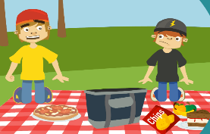  Unit 1 Bon appetit, bonne sante – Healthy Eating
AUTUMN 2 | Unit 2 Jeux et Chansons - Games and songs | 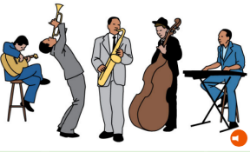  Unit 2 Je suis le musician –  I am the music man
SPRING 1 | Unit 3 On fait la fete – Celebrations | Unit 3 En route pour I’école –  On the way to school
SPRING 2 | Unit 4 Portraits – Portraits | 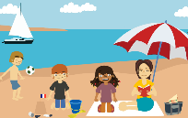  Unit 4 Scène de plage – Beach scene
SUMMER 1 | Unit 5 Les Quatre Amis –  The four friends | Unit 5 Le retour du printemps –  The return of spring
SUMMER 2 | Unit 6 Ca Pousse – Growing things | Unit 6 Les planets – The planets 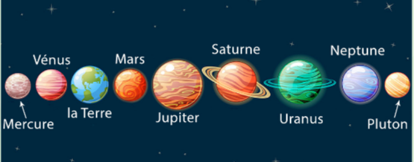

YEAR B | LOWER KS2 | UPPER KS2
AUTUMN 1 | Unit 1 On y va! – All aboard | Unit 1 Notre école – Our school
AUTUMN 2 | Unit 2 L’argent de poche – Pocket money | 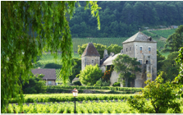  Unit 2 Notre monde – The world around us
SPRING 1 | Unit 3 Raconte – moi une histoire! – Tell me a story! | 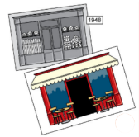  Unit 3 Le passé et le present – Then and now
SPRING 2 | Unit 4 Vive le sport! –  Our sporting lives | Unit 4 Ici et là – Out and about
SUMMER 1 | Unit 5 Le Carnaval des Animaux –  The Carnival of… | 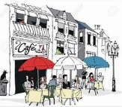  Unit 5 Monter un café – Setting up a café
SUMMER 2 | Unit 6 Quel temps fait-il? – What’s the weather like? | Unit 6 Quoi de neuf? – What’s in the news?

Rolling Programme – Information for parents
YEAR A | LOWER KS2 | UPPER KS2
AUTUMN 1 | Unit 1 Moi – All About Me | Unit 1 Bon appetit, bonne sante – Healthy Eating
AUTUMN 2 | Unit 2 Jeux et Chansons - Games and songs | Unit 2 Je suis le musician –  I am the music man
SPRING 1 | Unit 3 On fait la fete – Celebrations | Unit 3 En route pour I’école –  On the way to school
SPRING 2 | Unit 4 Portraits – Portraits | Unit 4 Scène de plage – Beach scene
SUMMER 1 | Unit 5 Les Quatre Amis –  The four friends | Unit 5 Le retour du printemps –  The return of spring
SUMMER 2 | Unit 6 Ca Pousse – Growing things | Unit 6 Les planets – The planets
YEAR B | LOWER KS2 | UPPER KS2
AUTUMN 1 | Unit 1 On y va! – All aboard | Unit 1 Notre école – Our school
AUTUMN 2 | Unit 2 L’argent de poche – Pocket money | Unit 2 Notre monde – The world around us
SPRING 1 | Unit 3 Raconte – moi une histoire! – Tell me a story! | Unit 3 Le passé et le present – Then and now
SPRING 2 | Unit 4 Vive le sport! – Our sporting lives | Unit 4 Ici et là – Out and about
SUMMER 1 | Unit 5 Le Carnaval des Animaux –  The Carnival of… | Unit 5 Monter un café – Setting up a café
SUMMER 2 | Unit 6 Quel temps fait-il? – What’s the weather like? | Unit 6 Quoi de neuf? – What’s in the news?

Rolling Programme – Pictures for curriculum display
 | Year A Aut 1 | Year A Aut 2 | Year A Spring 1 | Year A Spring 2 | Year A Summer 1 | Year A Summer 2 | Year B Aut 1 | Year B Aut 2 | Year B Spring 1 | Year B Spring 2 | Year B Summer 1 | Year B Summer 2
Lower KS2
Upper KS2 | 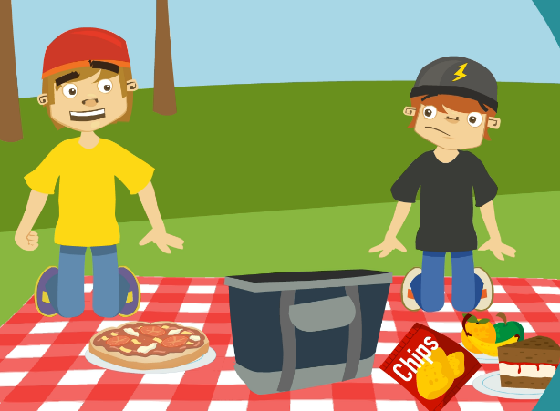 | 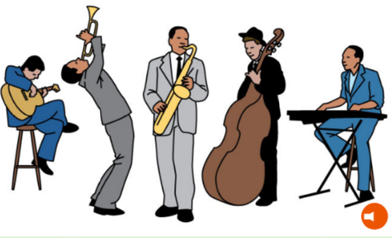 |  | 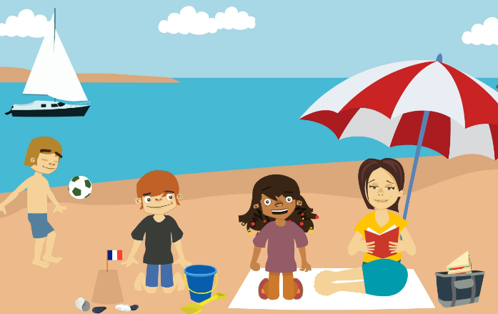 |  |  |  |  | 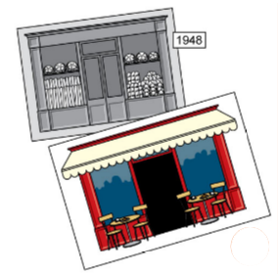 | 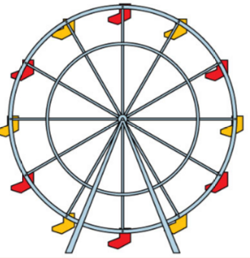 | 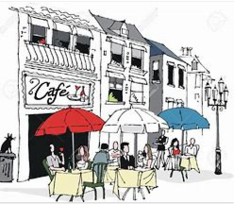

Resources for planning

*We follow a rolling programme to insure there is full coverage and content appropriate for our children in mixed age classes.
- *We use Rising Stars A complete curriculum programme for primary French (risingstars-uk.com) (I’m using Manda’s log in?)
- Within this link there are links to all planning and resources that teachers will need to deliver the programme of learning.
- There might be occasions other suitable websites are used. This will be decided by the specialist teacher ultimately to ensure our children have the best experience. If this is the case they will still be linked to the curriculum we have outlined above.
- Letterjoin Log In (letterjoin.co.uk)

Lesson Structure

Teyr and Peswara each have one, half an hour lesson a week to the delivery of French
Lessons are varied but comprise ultimately of opportunities to speak French, understand the basics of the language and practice written skills. There is opportunity to listen to French, watch videos, play games and sing songs in order to continually improve the accuracy of their pronunciation and intonation.
The lesson will cover the planned subject area as highlighted in the Programme Information.
French is also practiced during the week to support the learning taken place during the formal lesson.
There will be a working wall to assist children with their vocabulary and act as visual reminders around what is being taught.

Presentation Convention

In the classroom there will be a display board added to each week to be used as a visual aid in order for children to refer to and for teachers lead practicing the vocabulary at different opportunities across the week.
Completed written work will be kept for children to reflect on as appropriate in lessons and for teachers to assess this element of learning the language.

